11:00 am August 30, 2026
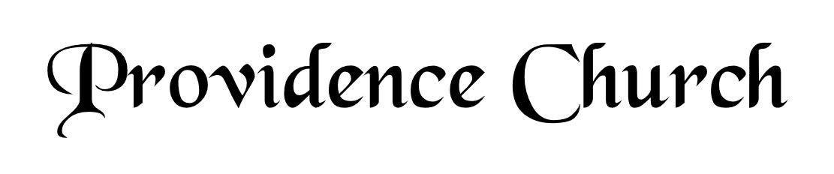
Welcome and Announcements
Silent Prayer

* Opening Praise Doxology
Praise God from whom all blessings flow
Praise him, all creatures here below
Praise him above, ye heavenly host
Praise Father, Son, and Holy Ghost. Amen.

* Call to Worship Psalm 98
Leader: Make a joyful noise to the Lord, all the earth;
People: Break forth into joyous song and sing praises!
Leader: Sing praises to the Lord with the lyre,
People: With the lyre and the sound of melody,
Leader: With trumpets and the sound of the horn;
People: Make a joyful noise before the King, the Lord!
* Prayer of Invocation

* Hymn
O How I Love Your Holy Law #119M

Scriptural Exhortation Psalm 51:1-5

Prayer of Confession
O God our Father, You are holy and wise, and just and true in all Your ways. We confess we minimize You in our thoughts; our view of You is not high enough. We do not think of ourselves as ruined sinners before a completely just and holy God; all our sins condemn us. Dear Father, forgive us and pardon us through Christ’s atoning sacrifice. We thank You for what our Lord Jesus has done for us on the cross; cleansing us, purifying us before You. What a blessing to know we have been restored to You. May we live in Your strength day by day. Through Christ our Lord we pray, Amen.
Assurance of Pardon 2 Corinthians 5:17-21

* Hymn of Response
Great Is Thy Faithfulness #245

* Affirmation of Faith Westminster Larger Catechism
Q31. With whom was the covenant of grace made?
A31. The covenant of grace was made with Christ as the second Adam, and in him with all the elect as his seed.

Q32. How is the grace of God manifested in the second covenant?
A32. The grace of God is manifested in the second covenant, in that he freely provideth and offereth to sinners a mediator, and life and salvation by him; and requiring faith as the condition to interest them in him, promiseth and giveth his Holy Spirit to all his elect, to work in them that faith, with all other saving graces; and to enable them unto all holy obedience, as the evidence of the truth of their faith and thankfulness to God, and as the way which he hath appointed them to salvation.

Prayer for the Covenant Community and Ruling Elder
The Lord’s Prayer Glenn Dowling
Our Father, Who art in heaven,
Hallowed be Thy name, Thy kingdom come,
Thy will be done, on earth as it is in heaven.
Give us this day our daily bread,
And forgive us our debts, as we forgive our debtors.
And lead us not into temptation,
But deliver us from evil,
For Thine is the kingdom, and the power,
And the glory forever, Amen.

Hymn
O for a Thousand Tongues to Sing #291

Sermon Text John 4:27-30
Sermon Come See a Man Rev. Stephen Payson

* The Apostles’ Creed
I believe in God the Father Almighty,
Maker of heaven and earth.
I believe in Jesus Christ, his only Son, our Lord
Who was conceived by the Holy Spirit,
And born of the virgin Mary,
He suffered under Pontius Pilate,
Was crucified, died, and was buried.
He descended into hell.
The third day he rose again from the dead.
He ascended into heaven.
And is seated at the right hand of God the Father Almighty.
From there He will come to judge the living and the dead.
I believe in the Holy Spirit, the holy catholic church,
The communion of saints, the forgiveness of sins,
The resurrection of the body, and the life Everlasting.

* Hymn
The Church’s One Foundation #404

* Benediction
Nursery Volunteer Rotation
Sunday 8/30/2026  Dan & Kate Wilkerson | Sunday 9/6/2026  Tim & Tessie West

