11:00 am August 9, 2026
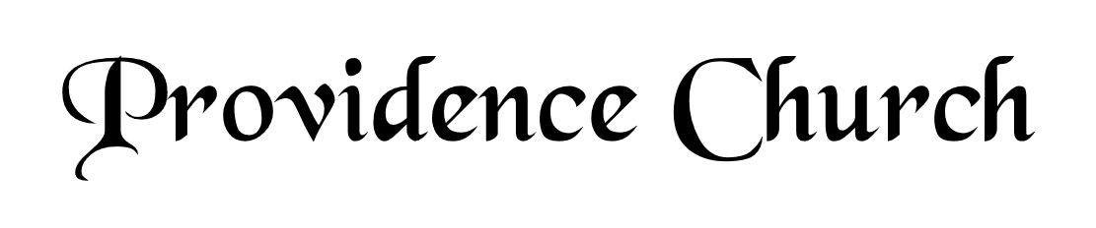
Welcome and Announcements
Silent Prayer

* Opening Praise Doxology
Praise God from whom all blessings flow
Praise him, all creatures here below
Praise him above, ye heavenly host
Praise Father, Son, and Holy Ghost. Amen.

* Call to Worship Psalm 149
Leader: Sing to the LORD a new song,
People: His praise in the assembly of the godly!
Leader: Let Israel be glad in his Maker;
People: Let the children of Zion rejoice in their King!
Leader: Jesus Christ is risen!
People: He is risen indeed!
* Prayer of Invocation

* Hymn
O How I Love Your Holy Law #119M

Scriptural Exhortation Hebrews 12:1-2

Prayer of Confession
O Father, it is my duty to set You above all others, but it is my besetting sin to place myself above You. I am pained by my shallow prayers, my poverty of love, and my slowness in running the heavenly race. I have wasted hours and passed by opportunities to do good. Forgive me for my many sins through the blood of Christ. You have begun a good work in me, and You have promised that You will bring it to completion. Make me reflect my citizenship in heaven even as I live on earth. In Christ’s name. Amen.
Assurance of Pardon Psalm 86:3-5

* Hymn of Response
O God beyond All Praising #241

* Affirmation of Faith Westminster Larger Catechism
Q27. What misery did the fall bring upon mankind?
A27. The fall brought upon mankind the loss of communion with God, his displeasure and curse; so as we are by nature children of wrath, bond slaves to Satan, and justly liable to all punishments in this world, and that which is to come.

Q28. What are the punishments of sin in this world?
A28. The punishments of sin in this world are either inward, as blindness of mind, a reprobate sense, strong delusions, hardness of heart, horror of conscience, and vile affections; or outward, as the curse of God upon the creatures for our sakes, and all other evils that befall us in our bodies, names, estates, relations, and employments; together with death itself.

Prayer for the Covenant Community and Teaching Elder
The Lord’s Prayer Mark Wheat
Our Father, Who art in heaven,
Hallowed be Thy name, Thy kingdom come,
Thy will be done, on earth as it is in heaven.
Give us this day our daily bread,
And forgive us our debts, as we forgive our debtors.
And lead us not into temptation,
But deliver us from evil,
For Thine is the kingdom, and the power,
And the glory forever, Amen.

Hymn
Fairest Lord Jesus #283

Sermon Text Job 1:1-5
Sermon An Introduction to Job Rev. Mark Wheat

* The Apostles’ Creed
I believe in God the Father Almighty,
Maker of heaven and earth.
I believe in Jesus Christ, his only Son, our Lord
Who was conceived by the Holy Spirit,
And born of the virgin Mary,
He suffered under Pontius Pilate,
Was crucified, died, and was buried.
He descended into hell.
The third day he rose again from the dead.
He ascended into heaven.
And is seated at the right hand of God the Father Almighty.
From there He will come to judge the living and the dead.
I believe in the Holy Spirit, the holy catholic church,
The communion of saints, the forgiveness of sins,
The resurrection of the body, and the life Everlasting.

* Hymn
Beneath the Cross of Jesus #350

* Benediction
Nursery Volunteer Rotation
Sunday 8/9/2026  Tim & Tessie West | Sunday 8/16/2026  Andrew & Regan van der Merwe

