11:00 am August 23, 2026
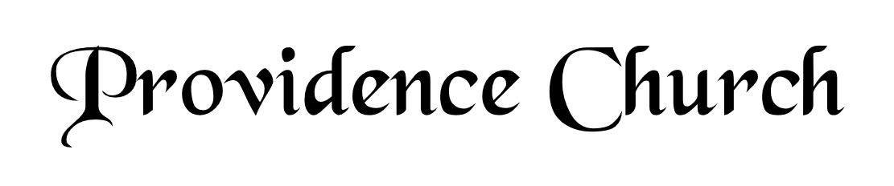
Welcome and Announcements
Silent Prayer

* Opening Praise Doxology
Praise God from whom all blessings flow
Praise him, all creatures here below
Praise him above, ye heavenly host
Praise Father, Son, and Holy Ghost. Amen.

* Call to Worship Psalm 148
Leader: Praise the Lord! Praise the Lord from the heavens,
People: Praise Him from the height.
Leader: Praise Him all His angels, praise Him, all His host!
People: Praise Him, sun and moon, praise Him, all you shining stars!
Leader: Praise Him, you highest heavens!
People: Let them praise the name of the Lord!
* Prayer of Invocation

* Hymn
O How I Love Your Holy Law #119M

Scriptural Exhortation Romans 12:1-2

Prayer of Confession
Most merciful Father, Your plan for us is to know, serve, and magnify You through Jesus Christ. By Your great love, You have opened our eyes to new life in Him. We confess our devotion to You is still very weak. We follow the lusts and pleasures of worldliness too easily. Forgive us. Wash us clean; purify us by the atoning sacrifice of Jesus Christ at the cross. Make our chief desire to love and honor You above all. Help us to press ever upward in the call of Christ, in whose name we pray. Amen.
Assurance of Pardon Romans 8:1-2

* Hymn of Response
A Mighty Fortress Is Our God #244

* Affirmation of Faith Westminster Larger Catechism
Q29. What are the punishments of sin in the world to come?
A29. The punishments of sin in the world to come, are everlasting separation from the comfortable presence of God, and most grievous torments in soul and body, without intermission, in hell-fire forever.

Q30. Doth God leave all mankind to perish in the estate of sin and misery?
A30. God doth not leave all men to perish in the estate of sin and misery, into which they fell by the breach of the first covenant, commonly called the covenant of works; but of his mere love and mercy delivereth his elect out of it, and bringeth them into an estate of salvation by the second covenant, commonly called the covenant of grace.

Prayer for the Covenant Community and Ruling Elder
The Lord’s Prayer Norval Sells
Our Father, Who art in heaven,
Hallowed be Thy name, Thy kingdom come,
Thy will be done, on earth as it is in heaven.
Give us this day our daily bread,
And forgive us our debts, as we forgive our debtors.
And lead us not into temptation,
But deliver us from evil,
For Thine is the kingdom, and the power,
And the glory forever, Amen.

Hymn
We Come, O Christ, to You #288

Sermon Text Job 1:1
Sermon Job: The Man (Part 2) Rev. Mark Wheat

* The Apostles’ Creed
I believe in God the Father Almighty,
Maker of heaven and earth.
I believe in Jesus Christ, his only Son, our Lord
Who was conceived by the Holy Spirit,
And born of the virgin Mary,
He suffered under Pontius Pilate,
Was crucified, died, and was buried.
He descended into hell.
The third day he rose again from the dead.
He ascended into heaven.
And is seated at the right hand of God the Father Almighty.
From there He will come to judge the living and the dead.
I believe in the Holy Spirit, the holy catholic church,
The communion of saints, the forgiveness of sins,
The resurrection of the body, and the life Everlasting.

* Hymn
Christ Is Made the Sure Foundation #402

* Benediction
Nursery Volunteer Rotation
Sunday 8/23/2026  Larry & Jennifer Watson | Sunday 8/30/2026  Dan & Kate Wilkerson

