11:00 am August 2, 2026
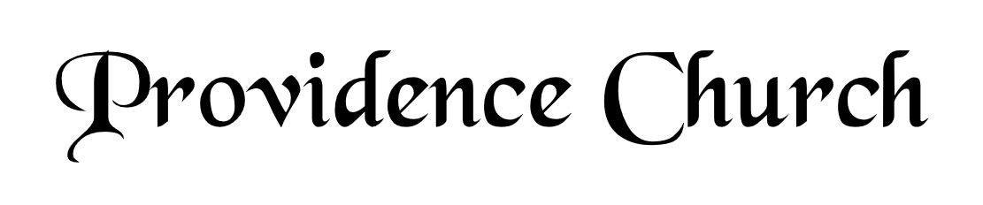
Welcome and Announcements
Silent Prayer

* Opening Praise Doxology
Praise God from whom all blessings flow
Praise him, all creatures here below
Praise him above, ye heavenly host
Praise Father, Son, and Holy Ghost. Amen.

* Call to Worship Psalm 105
Leader: Oh give thanks to the Lord, call upon His name,
People: Make known His deeds among the people!
Leader: Sing to Him, sing praises to Him;
People: Tell of all His Wondrous works!
Leader: Glory in His holy name;
People: Let the hearts of those who seek the Lord rejoice!
* Prayer of Invocation

* Hymn
O How I Love Your Holy Law #119M

Scriptural Exhortation Psalm 1:1-3

Prayer of Confession
God of grace and truth, in Jesus Christ you came among us as light shining in darkness, bringing the good news of joy that mankind is reconciled to God through Jesus. We confess that we have not welcomed the light, or trusted the good news. We have closed our eyes to your glory in our midst, and have ignored your presence in the Spirit of our Lord Jesus Christ. And, barely acknowledging in our lives Jesus’ first coming, we have not watched diligently for the final coming of our Savior and Judge. Forgive our sin, and renew our hope in the gospel, so that we may receive the fullness of your grace, and live in the truth of Christ our Lord, in whose name we pray. Amen.
Assurance of Pardon Romans 5:8-10

* Hymn of Response
Praise, My Soul, the King of Heaven #239

* Affirmation of Faith Westminster Larger Catechism
Q25. Wherein consisteth the sinfulness of that estate whereinto man fell?
A25. The sinfulness of that estate whereinto man fell, consisteth in the guilt of Adam’s first sin, the want of that righteousness wherein he was created, and the corruption of his nature, whereby he is utterly indisposed, disabled, and made opposite unto all that is spiritually good, and wholly inclined to all evil, and that continually; which is commonly called original sin, and from which do proceed all actual transgressions.

Q26. How is original sin conveyed from our first parents unto their posterity?
A26. Original sin is conveyed from our first parents unto their posterity by natural generation, so as all that proceed from them in that way are conceived and born in sin.

Prayer for the Covenant Community and Ruling Elder
The Lord’s Prayer Larry Watson
Our Father, Who art in heaven,
Hallowed be Thy name, Thy kingdom come,
Thy will be done, on earth as it is in heaven.
Give us this day our daily bread,
And forgive us our debts, as we forgive our debtors.
And lead us not into temptation,
But deliver us from evil,
For Thine is the kingdom, and the power,
And the glory forever, Amen.

Hymn
Rejoice, the Lord Is King #281

Sermon Text Philippians 1:21-26
Sermon Fruitful Labor Rev. Mark Wheat

* The Apostles’ Creed
I believe in God the Father Almighty,
Maker of heaven and earth.
I believe in Jesus Christ, his only Son, our Lord
Who was conceived by the Holy Spirit,
And born of the virgin Mary,
He suffered under Pontius Pilate,
Was crucified, died, and was buried.
He descended into hell.
The third day he rose again from the dead.
He ascended into heaven.
And is seated at the right hand of God the Father Almighty.
From there He will come to judge the living and the dead.
I believe in the Holy Spirit, the holy catholic church,
The communion of saints, the forgiveness of sins,
The resurrection of the body, and the life Everlasting.

* Hymn
What Wondrous Love Is This #343

* Benediction
Nursery Volunteer Rotation
Sunday 8/2/2026  Dan & Shirley Wilkerson | Sunday 8/9/2026  Tim & Tessie West

