11:00 am August 16, 2026
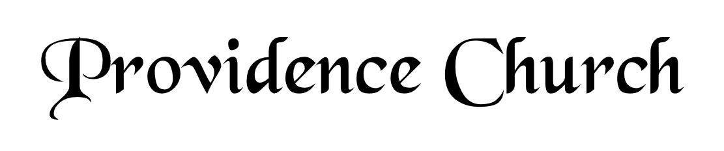
Welcome and Announcements
Silent Prayer

* Opening Praise Doxology
Praise God from whom all blessings flow
Praise him, all creatures here below
Praise him above, ye heavenly host
Praise Father, Son, and Holy Ghost. Amen.

* Call to Worship Psalm 111
Leader: We lift up our hearts to the Lord-Praise the Lord!
People: I will give thanks to the Lord with my whole heart.
Leader: Great are the works of the Lord,
People: Studied by all who delight in them.
Leader: Full of splendor and majesty is His work,
People: And His righteousness endures forever!
* Prayer of Invocation

* Hymn
O How I Love Your Holy Law #119M

Scriptural Exhortation Colossians 3:5-10

Prayer of Confession
Holy Father, we come before You in the righteousness of Christ, through whom we've been forgiven and justified, and we are thankful. We acknowledge Your claim on us: that we pursue righteousness—holy and obedient living that is blameless before God and man. How far we have fallen short in this. We confess that we have not pursued it with all our strength. We have not hated sin and loved righteousness, often doing the opposite instead. Please forgive our lukewarmness toward godly living. Wash us in the blood of our righteous Substitute, that we might die to sin and live to righteousness. For Jesus' sake we pray. Amen.
Assurance of Pardon I John 1:8-9

* Hymn of Response
How Firm a Foundation #243

* Affirmation of Faith Westminster Larger Catechism
Q29. How are we made partakers of the redemption purchased by Christ?
A29. We are made partakers of the redemption purchased by Christ, by the effectual application of it to us by his Holy Spirit.

Q30. How doth the Spirit apply to us the redemption purchased by Christ?
A30. The Spirit applieth to us the redemption purchased by Christ, by working faith in us, and thereby uniting us to Christ in our effectual calling.

Prayer for the Covenant Community and Ruling Elder
The Lord’s Prayer Dan Wilkerson
Our Father, Who art in heaven,
Hallowed be Thy name, Thy kingdom come,
Thy will be done, on earth as it is in heaven.
Give us this day our daily bread,
And forgive us our debts, as we forgive our debtors.
And lead us not into temptation,
But deliver us from evil,
For Thine is the kingdom, and the power,
And the glory forever, Amen.

Hymn
Let Us Love and Sing and Wonder #286

Sermon Text Job 1:1
Sermon Job: The Man Rev. Mark Wheat

* The Apostles’ Creed
I believe in God the Father Almighty,
Maker of heaven and earth.
I believe in Jesus Christ, his only Son, our Lord
Who was conceived by the Holy Spirit,
And born of the virgin Mary,
He suffered under Pontius Pilate,
Was crucified, died, and was buried.
He descended into hell.
The third day he rose again from the dead.
He ascended into heaven.
And is seated at the right hand of God the Father Almighty.
From there He will come to judge the living and the dead.
I believe in the Holy Spirit, the holy catholic church,
The communion of saints, the forgiveness of sins,
The resurrection of the body, and the life Everlasting.

* The Lord’s Supper

* Hymn
When I Survey the Wondrous Cross #338

* Benediction
Nursery Volunteer Rotation
Sunday 8/16/2026  Andrew & Regan van der Merwe | Sunday 8/23/2026  Larry & Jennifer Watson

