11:00 am July 5, 2026
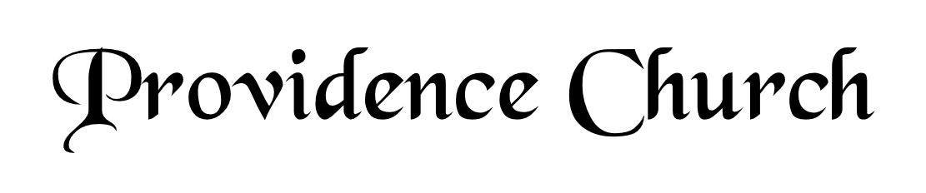
Welcome and Announcements
Silent Prayer

* Opening Praise Doxology
Praise God from whom all blessings flow
Praise him, all creatures here below
Praise him above, ye heavenly host
Praise Father, Son, and Holy Ghost. Amen.

* Call to Worship Psalm 66
Leader: Come and hear, all you who fear God.
People: And I will declare what He has done for my soul.
Leader: I cried to Him with my mouth.
People: And He was extolled with my tongue.
Leader: Jesus Christ is risen!
People: He is risen, indeed!
* Prayer of Invocation

* Hymn
O Come before the LORD, Our King #95A

Scriptural Exhortation Hebrews 12:1-2

Prayer of Confession
O God of Grace, you have attributed my sin on my substitute, and have imputed his righteousness to my soul, clothing me with a bridegroom’s robe, a robe of holiness. But in my walk, my daily living, I am still in rags. I have no robe to cover my sins, no loom to weave my own righteousness; I am always standing clothed in filthy garments, and by grace alone do I receive a change of clothes. For you justify the ungodly. I am always going into the far country, and always returning home as a prodigal, always saying, Father, forgive me, and thou are always bringing forth the best robe. Every morning let me wear it, every evening return in it, go out to the day’s work in it, be married in it, be wound in death in it, stand before the throne in it, enter heaven in it shining as the sun. Grant me never to lost sight of the exceeding sinfulness of sin, the exceeding righteousness of salvation, the exceeding glory of Christ, the exceeding beauty of holiness, the exceeding wonder of grace. Amen.
Assurance of Pardon Psalm 86:3-5

* Hymn of Response
Whate’er My God Ordains Is Right #231

* Affirmation of Faith Westminster Larger Catechism
Q18. What are God’s works of providence?
A18. God’s works of providence are his most holy, wise, and powerful preserving and governing all his creatures; ordering them, and all their actions, to his own glory.

Q19. What is God’s providence towards the angels?
A19. God by his providence permitted some of the angels, willfully and irrecoverably, to fall into sin and damnation, limiting and ordering that, and all their sins, to his own glory; and established the rest in holiness and happiness; employing them all, at his pleasure, in the administrations of his power, mercy, and justice.

Prayer for the Covenant Community and Teaching Elder
The Lord’s Prayer Mark Wheat
Our Father, Who art in heaven,
Hallowed be Thy name, Thy kingdom come,
Thy will be done, on earth as it is in heaven.
Give us this day our daily bread,
And forgive us our debts, as we forgive our debtors.
And lead us not into temptation,
But deliver us from evil,
For Thine is the kingdom, and the power,
And the glory forever, Amen.

Hymn
In Christ Alone #265

Sermon Text Jonah 4
Sermon The Angry Prophet! Rev. Mark Wheat

* The Apostles’ Creed
I believe in God the Father Almighty,
Maker of heaven and earth.
I believe in Jesus Christ, his only Son, our Lord
Who was conceived by the Holy Spirit,
And born of the virgin Mary,
He suffered under Pontius Pilate,
Was crucified, died, and was buried.
He descended into hell.
The third day he rose again from the dead.
He ascended into heaven.
And is seated at the right hand of God the Father Almighty.
From there He will come to judge the living and the dead.
I believe in the Holy Spirit, the holy catholic church,
The communion of saints, the forgiveness of sins,
The resurrection of the body, and the life Everlasting.

* Hymn
Just as I Am, without One Plea #453

* Benediction
Nursery Volunteer Rotation
Sunday 7/5/2026  Andrew & Regan van der Merwe | Sunday 7/12/2026  Larry & Jennifer Watson

