11:00 am July 26, 2026
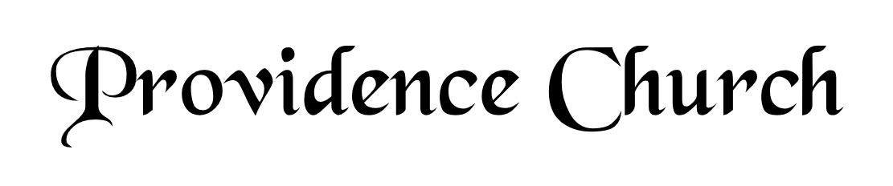
Welcome and Announcements
Silent Prayer

* Opening Praise Doxology
Praise God from whom all blessings flow
Praise him, all creatures here below
Praise him above, ye heavenly host
Praise Father, Son, and Holy Ghost. Amen.

* Call to Worship Psalm 96
Leader: Ascribe to the Lord, O families of the peoples,
People: Ascribe to the Lord glory and strength!
Leader: Ascribe to the Lord the glory due His name;
People: Bring an offering and come into His courts!
Leader: Worship the Lord in holy array;
People: Tremble before Him all the earth!
* Prayer of Invocation

* Hymn
O Come before the LORD, Our King #95A

Scriptural Exhortation Galatians 5:13-17

Prayer of Confession
O Lord God, eternal and almighty Father, we confess and acknowledge unfeignedly before thy holy majesty that we are poor sinners, conceived and born in iniquity and corruption, prone to do evil, incapable of any good, and that in our depravity we transgress thy holy commandments without end or ceasing: Wherefore we purchase for ourselves, through thy righteous judgment, our ruin and perdition. Nevertheless, O Lord, we are grieved that we have offended thee; and we condemn ourselves and our sins with true repentance, beseeching thy grace to relieve our distress. O God and Father most gracious and full of compassion, have mercy upon us in the name of thy Son, our Lord Jesus Christ. And as thou dost blot out our sins and stains, magnify and increase in us day by day the grace of thy Holy Spirit: that as we acknowledge our unrighteousness with all our heart, we may be moved by that sorrow which shall bring forth true repentance in us, mortifying all our sins, and producing in us the fruits of righteousness and innocence which are pleasing unto thee; through the same Jesus Christ Our Lord. Amen.
Assurance of Pardon Micah 7:18-19

* Hymn of Response
To God Be the Glory #236

* Affirmation of Faith Westminster Larger Catechism
Q22. Did all mankind fall in that first transgression?
A22. The covenant being made with Adam as a public person, not for himself only, but for his posterity, all mankind descending from him by ordinary generation, sinned in him, and fell with him in that first transgression.

Q23. Into what estate did the fall bring mankind?
A23. The fall brought mankind into an estate of sin and misery.

Q24. What is sin?
A24. Sin is any want of conformity unto, or transgression of, any law of God, given as a rule to the reasonable creature.

Prayer for the Covenant Community and Ruling Elder
The Lord’s Prayer Glenn Dowling
Our Father, Who art in heaven,
Hallowed be Thy name, Thy kingdom come,
Thy will be done, on earth as it is in heaven.
Give us this day our daily bread,
And forgive us our debts, as we forgive our debtors.
And lead us not into temptation,
But deliver us from evil,
For Thine is the kingdom, and the power,
And the glory forever, Amen.

Hymn
Wondrous King, All-Glorious #280

Sermon Text 1 Thessalonians 1:1-10
Sermon Why Does the Church Need Godly Men and Women? Rev. Mark Wheat

* The Apostles’ Creed
I believe in God the Father Almighty,
Maker of heaven and earth.
I believe in Jesus Christ, his only Son, our Lord
Who was conceived by the Holy Spirit,
And born of the virgin Mary,
He suffered under Pontius Pilate,
Was crucified, died, and was buried.
He descended into hell.
The third day he rose again from the dead.
He ascended into heaven.
And is seated at the right hand of God the Father Almighty.
From there He will come to judge the living and the dead.
I believe in the Holy Spirit, the holy catholic church,
The communion of saints, the forgiveness of sins,
The resurrection of the body, and the life Everlasting.

* Hymn
Stricken, Smitten, and Afflicted #342

* Benediction
Nursery Volunteer Rotation
Sunday 7/26/2026  Dan & Kate Wilkerson | Sunday 8/2/2026  Dan & Shirley Wilkerson

