11:00 am July 19, 2026
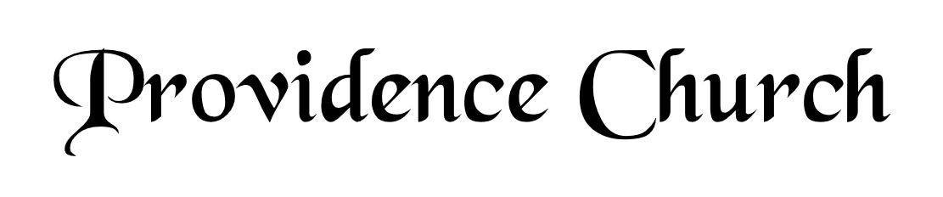
Welcome and Announcements
Silent Prayer

* Opening Praise Doxology
Praise God from whom all blessings flow
Praise him, all creatures here below
Praise him above, ye heavenly host
Praise Father, Son, and Holy Ghost. Amen.

* Call to Worship Psalm 99
Leader: The Lord reigns; let the peoples tremble!
People: He sits enthroned upon the cherubim; let the earth quake!
Leader: The Lord is great in Zion;
People: He is exalted over all the peoples.
Leader: Jesus Christ is risen!
People: He is risen indeed!
* Prayer of Invocation

* Hymn
O Come before the LORD, Our King #95A

Scriptural Exhortation Isaiah 5:20-23

Prayer of Confession
Almighty God, we are unworthy to come into your presence, because of our many sins. We do not deserve any grace or mercy from you, if you dealt with us as we deserve. We have sinned against you, O Lord, and we have offended you. And yet, O Lord, as we acknowledge our sins and offenses, so also do we acknowledge you to be a merciful God, a loving and favorable Father, to all who turn to you. And so we humbly ask you, for the sake of Christ your son, to show mercy to us, and forgive us all our offenses. Forgive the sins of our youth, and the sins of our old age. By your Spirit, O God, take possession of our hearts, so that, not only the actions of our life, but also the words of our mouths, and the smallest thought of our minds, may be guided and governed by you. Through Jesus Christ our Lord, to whom, with you and the Holy Spirit, be all honor and glory, now and forever. Amen.
Assurance of Pardon Psalm 85:2-3

* Hymn of Response
The God of Abraham Praise #234

* Affirmation of Faith Westminster Larger Catechism
Q22. How did Christ, being the Son of God, become man?
A22. Christ, the Son of God, became man, by taking to himself a true body and a reasonable soul, being conceived by the power of the Holy Ghost in the womb of the virgin Mary, and born of her, yet without sin.

Q23. What offices doth Christ execute as our redeemer?
A23. Christ, as our redeemer, executeth the offices of a prophet, of a priest, and of a king, both in his estate of humiliation and exaltation.

Prayer for the Covenant Community and Ruling Elder
The Lord’s Prayer Norval Sells
Our Father, Who art in heaven,
Hallowed be Thy name, Thy kingdom come,
Thy will be done, on earth as it is in heaven.
Give us this day our daily bread,
And forgive us our debts, as we forgive our debtors.
And lead us not into temptation,
But deliver us from evil,
For Thine is the kingdom, and the power,
And the glory forever, Amen.

Hymn
Arise, My Soul, Arise #275

Sermon Text 1 Corinthians 11:23-26
Sermon What is the Lord’s Supper? Rev. Mark Wheat

* The Apostles’ Creed
I believe in God the Father Almighty,
Maker of heaven and earth.
I believe in Jesus Christ, his only Son, our Lord
Who was conceived by the Holy Spirit,
And born of the virgin Mary,
He suffered under Pontius Pilate,
Was crucified, died, and was buried.
He descended into hell.
The third day he rose again from the dead.
He ascended into heaven.
And is seated at the right hand of God the Father Almighty.
From there He will come to judge the living and the dead.
I believe in the Holy Spirit, the holy catholic church,
The communion of saints, the forgiveness of sins,
The resurrection of the body, and the life Everlasting.

*The Lord’s Supper
* Hymn
O Sacred Head, Now Wounded #336

* Benediction
Nursery Volunteer Rotation
Sunday 7/19/2026  Maurice & Carolyn Carlson | Sunday 7/26/2026  Dan & Kate Wilkerson

