11:00 am July 12, 2026
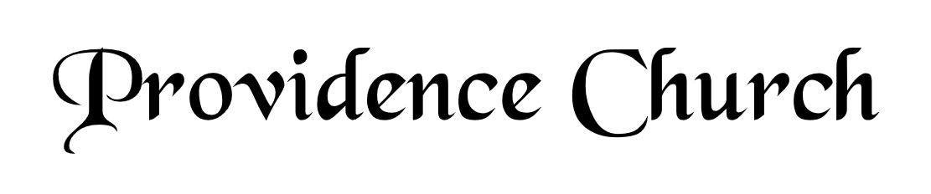
Welcome and Announcements
Silent Prayer

* Opening Praise Doxology
Praise God from whom all blessings flow
Praise him, all creatures here below
Praise him above, ye heavenly host
Praise Father, Son, and Holy Ghost. Amen.

* Call to Worship Psalm 133
Leader: Behold, how good and pleasant it is when brothers dwell in unity!
People: It is like the precious oil on the head, running down on the beard, on the beard of Aaron, running down on the collar of his robes!
Leader: It is like the dew of Hermon, which falls on the mountains of Zion!
People: For there the Lord has commanded the blessing, life forevermore.
Leader: Jesus Christ is risen!
People: He is risen indeed.
* Prayer of Invocation

* Hymn
O Come before the LORD, Our King #95A

Scriptural Exhortation Romans 12:1-2

Prayer of Confession
Almighty God, we confess this morning that by nature and practice we are sinners, for this is what Your Word teaches. We ask that as You showed mercy to the publican, that You would show mercy to us as well. Father, we abhor our indolence, envy, meanness, and pride. We ask that You would forgive and kill these vices in us. Have mercy on our unbelief and upon our corrupt and often wandering hearts. Forgive us for setting our affections on the things of the world. Grant that we would daily take refuge in that fountain that cleanses us from all sin. This we ask in Jesus’ name, Amen.
Assurance of Pardon Psalm 130:3-4

* Hymn of Response
O Father, You Are Sovereign #233

* Affirmation of Faith Westminster Larger Catechism
Q20. What was the providence of God toward man in the estate in which he was created?
A20. The providence of God toward man in the estate in which he was created, was the placing him in paradise, appointing him to dress it, giving him liberty to eat of the fruit of the earth; putting the creatures under his dominion, and ordaining marriage for his help; affording him communion with himself; instituting the Sabbath; entering into a covenant of life with him, upon condition of personal, perfect, and perpetual obedience, of which the tree of life was a pledge; and forbidding to eat of the tree of the knowledge of good and evil, upon the pain of death.

Q21. Did man continue in that estate wherein God at first created him?
A21. Our first parents being left to the freedom of their own will, through the temptation of Satan, transgressed the commandment of God in eating the forbidden fruit; and thereby fell from the estate of innocency wherein they were created.

Prayer for the Covenant Community and Ruling Elder
The Lord’s Prayer Dan Wilkerson
Our Father, Who art in heaven,
Hallowed be Thy name, Thy kingdom come,
Thy will be done, on earth as it is in heaven.
Give us this day our daily bread,
And forgive us our debts, as we forgive our debtors.
And lead us not into temptation,
But deliver us from evil,
For Thine is the kingdom, and the power,
And the glory forever, Amen.

Hymn
Break Thou the Bread of Life #273

Sermon Text Philippians 1:21-26
Sermon The Desire to be With Christ Rev. Mark Wheat

* The Apostles’ Creed
I believe in God the Father Almighty,
Maker of heaven and earth.
I believe in Jesus Christ, his only Son, our Lord
Who was conceived by the Holy Spirit,
And born of the virgin Mary,
He suffered under Pontius Pilate,
Was crucified, died, and was buried.
He descended into hell.
The third day he rose again from the dead.
He ascended into heaven.
And is seated at the right hand of God the Father Almighty.
From there He will come to judge the living and the dead.
I believe in the Holy Spirit, the holy catholic church,
The communion of saints, the forgiveness of sins,
The resurrection of the body, and the life Everlasting.

* Hymn
Jesus! What a Friend for Sinners! #456

* Benediction
Nursery Volunteer Rotation
Sunday 7/12/2026  Larry & Jennifer Watson | Sunday 7/19/2026  Maurice & Carolyn Carlson

