11:00 am June 7, 2026
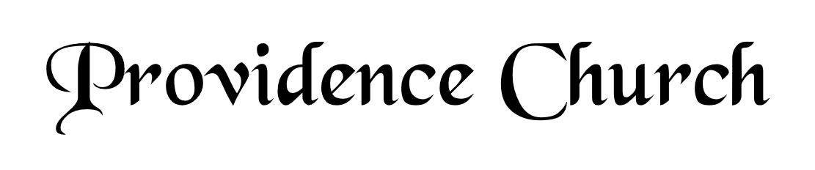
Welcome and Announcements
Silent Prayer

* Opening Praise Doxology
Praise God from whom all blessings flow
Praise him, all creatures here below
Praise him above, ye heavenly host
Praise Father, Son, and Holy Ghost. Amen.

* Call to Worship Isaiah 55
Leader: Seek the LORD while He may be found.
People: Call upon Him while He is near.
Leader: Let the wicked forsake his way, and the unrighteous man his thoughts.
People: Let him return to the LORD, that He may have compassion on him.
Leader: Jesus Christ is risen!
People: He is risen indeed!
* Prayer of Invocation

* Hymn
Wholehearted Thanksgiving #9B

Scriptural Exhortation Psalm 25:8-10

Prayer of Confession
Almighty Father; we enter your presence confessing the things we try to conceal from you and the things we try to conceal from others. We confess the heartbreak, worry, and sorrow we have caused, that make it difficult for others to forgive us, the times we have made it easy for others to do wrong, the harm we have done that makes it hard for us to forgive ourselves. Lord have mercy and forgive us through Christ. Amen.
Assurance of Pardon Psalm 130:1-4

* Hymn of Response
Thee We Adore, Eternal Lord! #223

* Affirmation of Faith Westminster Larger Catechism
Q10. What are the personal properties of the three persons in the Godhead?
A10. It is proper to the Father to beget the Son, and to the Son to be begotten of the Father, and to the Holy Ghost to proceed from the Father and the Son from all eternity.

Q11. How doth it appear that the Son and the Holy Ghost are God equal with the Father?
A11. The Scriptures manifest that the Son and the Holy Ghost are God equal with the Father, ascribing unto them such names, attributes, works, and worship, as are proper to God only.

Prayer for the Covenant Community and Ruling Elder
The Lord’s Prayer Dan Wilkerson
Our Father, Who art in heaven,
Hallowed be Thy name, Thy kingdom come,
Thy will be done, on earth as it is in heaven.
Give us this day our daily bread,
And forgive us our debts, as we forgive our debtors.
And lead us not into temptation,
But deliver us from evil,
For Thine is the kingdom, and the power,
And the glory forever, Amen.
Hymn
Though Troubles Assail Us #246

Sermon Text Jonah 1:1-17
Sermon Jonah Flees From the Presence of the Lord Rev. Mark Wheat

* The Apostles’ Creed
I believe in God the Father Almighty,
Maker of heaven and earth.
I believe in Jesus Christ, his only Son, our Lord
Who was conceived by the Holy Spirit,
And born of the virgin Mary,
He suffered under Pontius Pilate,
Was crucified, died, and was buried.
He descended into hell.
The third day he rose again from the dead.
He ascended into heaven.
And is seated at the right hand of God the Father Almighty.
From there He will come to judge the living and the dead.
I believe in the Holy Spirit, the holy catholic church,
The communion of saints, the forgiveness of sins,
The resurrection of the body, and the life Everlasting.

* Hymn
Be Thou My Vision #446

* Benediction
Nursery Volunteer Rotation
Sunday 6/7/2026  Larry & Jennifer Watson | Sunday 6/14/2026  Maurice & Carolyn Carlson

