11:00 am June 28, 2026
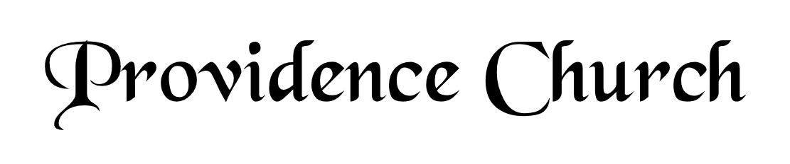
Welcome and Announcements
Silent Prayer

* Opening Praise Doxology
Praise God from whom all blessings flow
Praise him, all creatures here below
Praise him above, ye heavenly host
Praise Father, Son, and Holy Ghost. Amen.

* Call to Worship Psalm 134
Leader: Come, bless the Lord,
People: All you servants of the Lord,
Leader: Who stand by night in the House of the Lord.
People: Lift up your hands to the Holy place, and Bless the Lord.
Leader: Jesus Christ is risen!
People: He is risen, indeed!
* Prayer of Invocation

* Hymn
The Lord’s My Shepherd #23A

Scriptural Exhortation Matthew 22:34-40

Prayer of Confession
Gracious Father, we confess that with Adam, from the Garden, we have broken Your covenant. We daily fall short of Your standard of holiness. Because of our sin, we condemn ourselves daily. We deserve eternal death. Yet, Father, we thank You for Your mercy. While in our sin, You promised and sent Your Son to bear our sins. He has kept the covenant for us. He has lived and died on our behalf. Because of Your Son, Jesus Christ, forgive us. We thank You for the eternal life accomplished by what He has done for us. Renew us to live in Your strength, to do Your will. Through Christ we pray. Amen.
Assurance of Pardon I John 1:8-9

* Hymn of Response
Holy, Holy, Holy! #230

* Affirmation of Faith Westminster Larger Catechism
Q16. How did God create angels?
A16. God created all the angels spirits, immortal, holy, excelling in knowledge, mighty in power, to execute his commandments, and to praise his name, yet subject to change.

Q17. How did God create man?
A17. After God had made all other creatures, he created man male and female; formed the body of the man of the dust of the ground, and the woman of the rib of the man, endued them with living, reasonable, and immortal souls; made them after his own image, in knowledge, righteousness, and holiness; having the law of God written in their hearts, and power to fulfill it, and dominion over the creatures; yet subject to fall.

Prayer for the Covenant Community and Ruling Elder
The Lord’s Prayer Larry Watson
Our Father, Who art in heaven,
Hallowed be Thy name, Thy kingdom come,
Thy will be done, on earth as it is in heaven.
Give us this day our daily bread,
And forgive us our debts, as we forgive our debtors.
And lead us not into temptation,
But deliver us from evil,
For Thine is the kingdom, and the power,
And the glory forever, Amen.

Hymn
All Glory, Laud, and Honor #325

Sermon Text John 17:1-3
Sermon This Is Life Eternal Rev. Bill Fitzhenry

* The Apostles’ Creed
I believe in God the Father Almighty,
Maker of heaven and earth.
I believe in Jesus Christ, his only Son, our Lord
Who was conceived by the Holy Spirit,
And born of the virgin Mary,
He suffered under Pontius Pilate,
Was crucified, died, and was buried.
He descended into hell.
The third day he rose again from the dead.
He ascended into heaven.
And is seated at the right hand of God the Father Almighty.
From there He will come to judge the living and the dead.
I believe in the Holy Spirit, the holy catholic church,
The communion of saints, the forgiveness of sins,
The resurrection of the body, and the life Everlasting.

* Hymn
Jesus Loves Me, This I Know #478

* Benediction
Nursery Volunteer Rotation
Sunday 6/28/2026  Dan & Shirley Wilkerson | Sunday 7/5/2026  Andrew & Regan van der Merwe

