11:00 am June 14, 2026
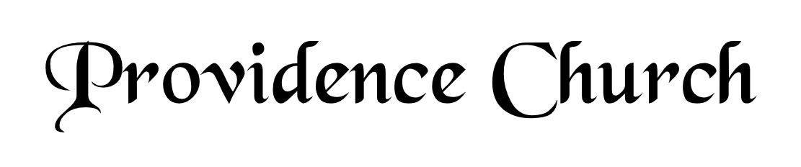
Welcome and Announcements
Silent Prayer

* Opening Praise Doxology
Praise God from whom all blessings flow
Praise him, all creatures here below
Praise him above, ye heavenly host
Praise Father, Son, and Holy Ghost. Amen.

* Call to Worship Isaiah 12
Leader: Give thanks to the LORD, call upon His name!
People: Make known His deeds among the peoples, proclaim that His name is exalted.
Leader: Sing praises to the LORD!
People: For He has done gloriously!
Leader: Jesus Christ is risen!
People: He is risen, indeed!
* Prayer of Invocation

* Hymn
Wholehearted Thanksgiving #9B

Scriptural Exhortation John 15:9-14

Prayer of Confession
We come to You, Father, Son, and Holy Spirit, confessing that we have been disobedient to Your commandment to love one another. We show interest in each other, but we often do not want to be inconvenienced. We often protect our time, comfort, and space. Forgive us by the death of Jesus Christ, Your Son. Remove from us our guilt and shame and give us genuine repentance. Make us more Christ-like; take away our selfishness; give us a willing heart to share His love with others, to sacrifice our time and comfort for others. In His holy name we pray. Amen.
Assurance of Pardon Ephesians 1:7

* Hymn of Response
Immortal, Invisible, God Only Wise #224

* Affirmation of Faith Westminster Larger Catechism
Q12. What are the decrees of God?
A12. God’s decrees are the wise, free, and holy acts of the counsel of his will, whereby, from all eternity, he hath, for his own glory, unchangeably foreordained whatsoever comes to pass in time, especially concerning angels and men.

Q13. What hath God especially decreed concerning angels and men?
A13. God, by an eternal and immutable decree, out of his mere love, for the praise of his glorious grace, to be manifested in due time, hath elected some angels to glory; and in Christ hath chosen some men to eternal life, and the means thereof: and also, according to his sovereign power, and the unsearchable counsel of his own will (whereby he extendeth or withholdeth favor as he pleaseth), hath passed by and foreordained the rest to dishonor and wrath, to be for their sin inflicted, to the praise of the glory of his justice.

Prayer for the Covenant Community and Ruling Elder
The Lord’s Prayer Norval Sells
Our Father, Who art in heaven,
Hallowed be Thy name, Thy kingdom come,
Thy will be done, on earth as it is in heaven.
Give us this day our daily bread,
And forgive us our debts, as we forgive our debtors.
And lead us not into temptation,
But deliver us from evil,
For Thine is the kingdom, and the power,
And the glory forever, Amen.

Hymn
All Creatures of Our God and King #248

Sermon Text Jonah 2
Sermon Jonah Prayed: Misery, Mercy, Salvation Rev. Mark Wheat

* The Apostles’ Creed
I believe in God the Father Almighty,
Maker of heaven and earth.
I believe in Jesus Christ, his only Son, our Lord
Who was conceived by the Holy Spirit,
And born of the virgin Mary,
He suffered under Pontius Pilate,
Was crucified, died, and was buried.
He descended into hell.
The third day he rose again from the dead.
He ascended into heaven.
And is seated at the right hand of God the Father Almighty.
From there He will come to judge the living and the dead.
I believe in the Holy Spirit, the holy catholic church,
The communion of saints, the forgiveness of sins,
The resurrection of the body, and the life Everlasting.

* Hymn
Approach, My Soul, the Mercy Seat #451

* Benediction
Nursery Volunteer Rotation
Sunday 6/14/2026  Maurice & Carolyn Carlson | Sunday 6/21/2026  Dan & Kate Wilkerson

