11:00 am May 3, 2026
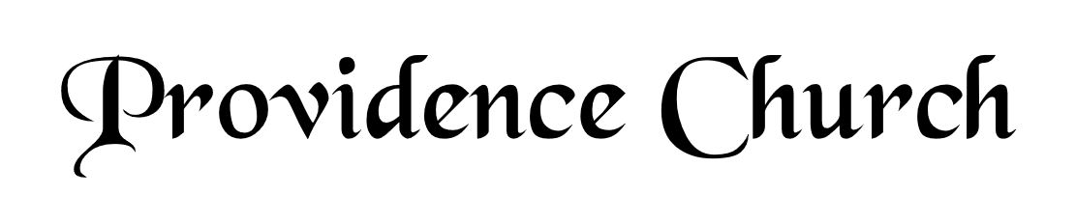
Welcome and Announcements
Silent Prayer

* Opening Praise Doxology
Praise God from whom all blessings flow
Praise him, all creatures here below
Praise him above, ye heavenly host
Praise Father, Son, and Holy Ghost. Amen.

* Call to Worship Psalm 117
Leader: Praise the Lord, all nations!
People: Extol Him, all peoples!
Leader: For great is His steadfast love toward us,
People: And the faithfulness of the LORD endures forever.
Leader: Jesus Christ is risen!
People: He is risen indeed!
* Prayer of Invocation

* Hymn
O Come, My Soul, Bless Thou the Lord #103E

Scriptural Exhortation Romans 12:1-2

Prayer of Confession
Most merciful God, we confess that we have sinned against you in thought, word, and deed, by what we have done, and by what we have left undone. We have not loved you with our whole heart; we have not loved our neighbors as ourselves. We are truly sorry and we humbly repent, for the sake of your Son Jesus Christ, have mercy on us and forgive us; that we may delight in your will, and walk in your ways, to the glory of your Name. Amen.
Assurance of Pardon Psalm 130:3-4

* Hymn of Response
Come, Thou Almighty King #212

* Affirmation of Faith Westminster Larger Catechism
Q154. What are the outward means whereby Christ communicates to us the benefits of his mediation?
A154. The outward and ordinary means whereby Christ communicates to his church the benefits of his mediation, are all his ordinances; especially the word, sacraments, and prayer; all which are made effectual to the elect for their salvation.

Q155. How is the word made effectual to salvation?
A155. The Spirit of God maketh the reading, but especially the preaching of the word, an effectual means of enlightening, convincing, and humbling sinners; of driving them out of themselves, and drawing them unto Christ; of conforming them to his image, and subduing them to his will; of strengthening them against temptations and corruptions; of building them up in grace, and establishing their hearts in holiness and comfort through faith unto salvation.

Prayer for the Covenant Community and Ruling Elder
The Lord’s Prayer Norval Sells
Our Father, Who art in heaven,
Hallowed be Thy name, Thy kingdom come,
Thy will be done, on earth as it is in heaven.
Give us this day our daily bread,
And forgive us our debts, as we forgive our debtors.
And lead us not into temptation,
But deliver us from evil,
For Thine is the kingdom, and the power,
And the glory forever, Amen.

Hymn
Praise, My Soul, the King of Heaven #239

Sermon Text Matthew 13:45-46
Sermon Preparing for the Future Part 2 Rev. Mark Wheat

* The Apostles’ Creed
I believe in God the Father Almighty,
Maker of heaven and earth.
I believe in Jesus Christ, his only Son, our Lord
Who was conceived by the Holy Spirit,
And born of the virgin Mary,
He suffered under Pontius Pilate,
Was crucified, died, and was buried.
He descended into hell.
The third day he rose again from the dead.
He ascended into heaven.
And is seated at the right hand of God the Father Almighty.
From there He will come to judge the living and the dead.
I believe in the Holy Spirit, the holy catholic church,
The communion of saints, the forgiveness of sins,
The resurrection of the body, and the life Everlasting.

* Hymn
My Faith Has Found a Resting Place #436

* Benediction
Nursery Volunteer Rotation
Sunday 5/3/2026  Larry & Jennifer Watson | Sunday 5/10/2026  Dan & Kate Wilkerson

