11:00 am May 24, 2026
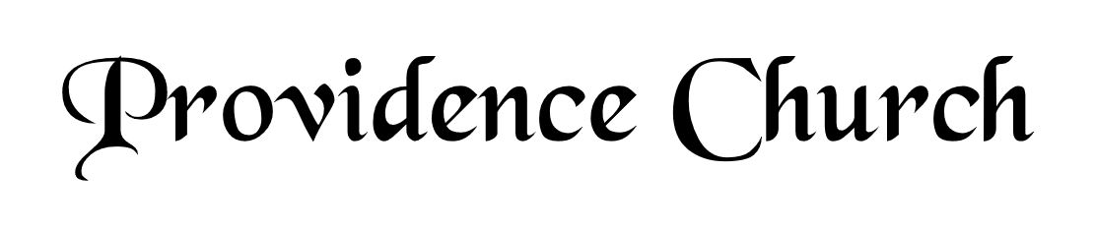
Welcome and Announcements
Silent Prayer

* Opening Praise Doxology
Praise God from whom all blessings flow
Praise him, all creatures here below
Praise him above, ye heavenly host
Praise Father, Son, and Holy Ghost. Amen.

* Call to Worship Psalm 117
Leader: Praise the Lord, all nations!
People: Extol him, all peoples!
Leader: For great is his steadfast love toward us,
People: And the faithfulness of the Lord endures forever. Praise the Lord!
* Prayer of Invocation

* Hymn
O Come, My Soul, Bless Thou the Lord #103E

Scriptural Exhortation Colossians 3:5-10

Prayer of Confession
Holy Father, we come before You in the righteousness of Christ, through whom we've been forgiven and justified, and we are thankful. We acknowledge Your claim on us: that we pursue righteousness—holy and obedient living that is blameless before God and man. How far we have fallen short in this. We confess that we have not pursued it with all our strength. We have not hated sin and loved righteousness, often doing the opposite instead. Please forgive our lukewarmness toward godly living. Wash us in the blood of our righteous Substitute, that we might die to sin and live to righteousness. For Jesus' sake we pray. Amen.
Assurance of Pardon I John 1:8-9

* Hymn of Response
O Worship the King #219

* Affirmation of Faith Westminster Larger Catechism
Q6. What do the Scriptures make known of God?
A6. The Scriptures make known what God is, the persons in the Godhead, his decrees, and the execution of his decrees.

Q7. What is God?
A7. God is a Spirit, in and of himself infinite in being, glory, blessedness, and perfection; all-sufficient, eternal, unchangeable, incomprehensible, everywhere present, almighty, knowing all things, most wise, most holy, most just, most merciful and gracious, longsuffering, and abundant in goodness and truth.

Prayer for the Covenant Community and Ruling Elder
The Lord’s Prayer Norval Sells
Our Father, Who art in heaven,
Hallowed be Thy name, Thy kingdom come,
Thy will be done, on earth as it is in heaven.
Give us this day our daily bread,
And forgive us our debts, as we forgive our debtors.
And lead us not into temptation,
But deliver us from evil,
For Thine is the kingdom, and the power,
And the glory forever, Amen.

Hymn
A Mighty Fortress Is Our God #244

Sermon Text Psalm 145
Sermon The Saint’s Comforts - II Rev. Bill Fitzhenry

* The Apostles’ Creed
I believe in God the Father Almighty,
Maker of heaven and earth.
I believe in Jesus Christ, his only Son, our Lord
Who was conceived by the Holy Spirit,
And born of the virgin Mary,
He suffered under Pontius Pilate,
Was crucified, died, and was buried.
He descended into hell.
The third day he rose again from the dead.
He ascended into heaven.
And is seated at the right hand of God the Father Almighty.
From there He will come to judge the living and the dead.
I believe in the Holy Spirit, the holy catholic church,
The communion of saints, the forgiveness of sins,
The resurrection of the body, and the life Everlasting.

* Hymn
We Praise You, O God, Our Redeemer, Creator #247

* Benediction
Nursery Volunteer Rotation
Sunday 5/24/2026  Andrew & Regan van der Merwe | Sunday 5/31/2026  Dan & Shirley Wilkerson

