11:00 am May 10, 2026
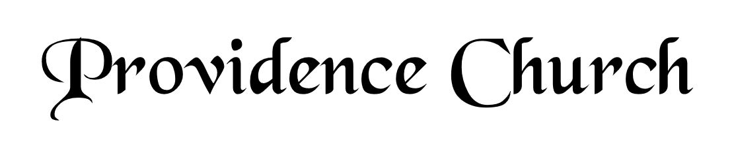
Welcome and Announcements
Silent Prayer

* Opening Praise Doxology
Praise God from whom all blessings flow
Praise him, all creatures here below
Praise him above, ye heavenly host
Praise Father, Son, and Holy Ghost. Amen.

* Call to Worship Psalm 33
Leader: Shout for joy in the LORD, O you righteous!
People: Praise befits the upright. Give thanks to the LORD with the lyre.
Leader: Make melody to Him with the harp of ten strings.
People: Sing to Him a new song; play skillfully on the strings, with loud shouts.
Leader: Jesus Christ Is Risen!
People: He Is Risen Indeed!
* Prayer of Invocation

* Hymn
O Come, My Soul, Bless Thou the Lord #103E

Scriptural Exhortation Psalm 1:1-3

Prayer of Confession
Almighty and most merciful Father, we have erred and strayed from Your ways like lost sheep. We have followed too much the devices and desires of our own hearts. We have offended against Your holy laws. We have left undone those things which we ought to have done; and we have done those things which we ought not to have done; and there is nothing good in us. O Lord, have mercy upon us, miserable offenders. Spare those, O God, who confess their faults. Restore those who are penitent; according to Your promises declared unto men in Christ Jesus our Lord. Grant that we may hereafter live a godly, righteous, and sober life; to the glory of His name. Amen.
Assurance of Pardon Romans 5:8-10

* Hymn of Response
Give to Our God Immortal Praise #215

* Affirmation of Faith Westminster Larger Catechism
Q140. Which is the eighth commandment?
A140. The eighth commandment is, Thou shalt not steal.

Q141. What are the duties required in the eighth commandment?
A141. The duties required in the eighth commandment are, truth, faithfulness, and justice in contracts and commerce between man and man; rendering to every one his due; restitution of goods unlawfully detained from the right owners thereof; giving and lending freely, according to our abilities, and the necessities of others; moderation of our judgments, wills, and affections concerning worldly goods; a provident care and study to get, keep, use, and dispose these things which are necessary and convenient for the sustentation of our nature, and suitable to our condition; a lawful calling, and diligence in it; frugality; avoiding unnecessary lawsuits, and suretiship, or other like engagements; and an endeavor, by all just and lawful means, to procure, preserve, and further the wealth and outward estate of others, as well as our own.

Prayer for the Covenant Community and Ruling Elder
The Lord’s Prayer Glenn Dowling
Our Father, Who art in heaven,
Hallowed be Thy name, Thy kingdom come,
Thy will be done, on earth as it is in heaven.
Give us this day our daily bread,
And forgive us our debts, as we forgive our debtors.
And lead us not into temptation,
But deliver us from evil,
For Thine is the kingdom, and the power,
And the glory forever, Amen.

Hymn
O God beyond All Praising #241

Sermon Text Acts 2:42
Sermon Preparing for the Future Part 3 Rev. Mark Wheat

* The Apostles’ Creed
I believe in God the Father Almighty,
Maker of heaven and earth.
I believe in Jesus Christ, his only Son, our Lord
Who was conceived by the Holy Spirit,
And born of the virgin Mary,
He suffered under Pontius Pilate,
Was crucified, died, and was buried.
He descended into hell.
The third day he rose again from the dead.
He ascended into heaven.
And is seated at the right hand of God the Father Almighty.
From there He will come to judge the living and the dead.
I believe in the Holy Spirit, the holy catholic church,
The communion of saints, the forgiveness of sins,
The resurrection of the body, and the life Everlasting.

* Hymn
I Love to Tell the Story #438

* Benediction
Nursery Volunteer Rotation
Sunday 5/10/2026  Dan & Kate Wilkerson | Sunday 5/17/2026  Tim & Tessie West

