11:00 am April 5, 2026
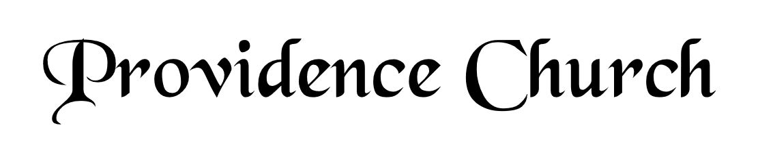
Welcome and Announcements
Silent Prayer

* Opening Praise Doxology
Praise God from whom all blessings flow
Praise him, all creatures here below
Praise him above, ye heavenly host
Praise Father, Son, and Holy Ghost. Amen.

* Call to Worship Nehemiah 9
Leader: Stand up and praise the LORD your God, who is from everlasting to everlasting!
People: Blessed be Your glorious name, which is exalted above all blessing and praise.
Leader: You are the LORD, you alone!
People: You are the Creator and Preserver of all; You are the LORD, our God for Whom we gather to worship.
Leader: Jesus Christ is Risen!
People: He is Risen Indeed!
* Prayer of Invocation

* Hymn
Christ the Lord Is Risen Today #360

Scriptural Exhortation Proverbs 28:13

Prayer of Confession
God of grace and truth, in Jesus Christ you came among us as light shining in darkness, bringing the good news of joy that mankind is reconciled to God through Jesus. We confess that we have not welcomed the light or trusted the good news. We have closed our eyes to your glory in our midst, and have ignored your presence in the Spirit of our Lord Jesus Christ. And, barely acknowledging in our lives Jesus’ first coming, we have not watched diligently for the final coming of our Savior and Judge. Forgive our sin, and renew our hope in the gospel, so that we may receive the fullness of your grace, and live in the truth of Christ our Lord, in whose name we pray. Amen.
Assurance of Pardon I John 1:8-9

Baptism Bennett Cecil van der Merwe

* Hymn of Response
Come, Ye Faithful, Raise the Strain #356

* Affirmation of Faith Westminster Larger Catechism
Q51. What was the estate of Christ’s exaltation?
A51. The estate of Christ’s exaltation comprehendeth his resurrection, ascension, sitting at the right hand of the Father, and his coming again to judge the world.

Q52. How was Christ exalted in his resurrection?
A52. Christ was exalted in his resurrection, in that, not having seen corruption in death (of which it was not possible for him to be held), and having the very same body in which he suffered, with the essential properties thereof (but without mortality, and other common infirmities belonging to this life), really united to his soul, he rose again from the dead the third day by his own power; whereby he declared himself to be the Son of God, to have satisfied divine justice, to have vanquished death, and him that had power of it, and to be Lord of quick and dead: all which he did as a public person, the head of his church, for their justification, quickening in grace, support against enemies, and to assure them of their resurrection from the dead at the last day.

Prayer for the Covenant Community and Ruling Elder
The Lord’s Prayer Glenn Dowling
Our Father, Who art in heaven,
Hallowed be Thy name, Thy kingdom come,
Thy will be done, on earth as it is in heaven.
Give us this day our daily bread,
And forgive us our debts, as we forgive our debtors.
And lead us not into temptation,
But deliver us from evil,
For Thine is the kingdom, and the power,
And the glory forever, Amen.

Hymn
Worship Christ, the Risen King! #369

Sermon Text Psalm 22:22-31
Sermon Appropriating the Feast Rev. Mark Wheat

* The Apostles’ Creed
I believe in God the Father Almighty,
Maker of heaven and earth.
I believe in Jesus Christ, his only Son, our Lord
Who was conceived by the Holy Spirit,
And born of the virgin Mary,
He suffered under Pontius Pilate,
Was crucified, died, and was buried.
He descended into hell.
The third day he rose again from the dead.
He ascended into heaven.
And is seated at the right hand of God the Father Almighty.
From there He will come to judge the living and the dead.
I believe in the Holy Spirit, the holy catholic church,
The communion of saints, the forgiveness of sins,
The resurrection of the body, and the life Everlasting.

* Hymn
Up from the Grave He Arose #367

* Benediction
Nursery Volunteer Rotation
Sunday 4/5/2026  No Volunteers for Easter Sunday | Sunday 4/12/2026  Tim & Tessie West

