11:00 am April 19, 2026
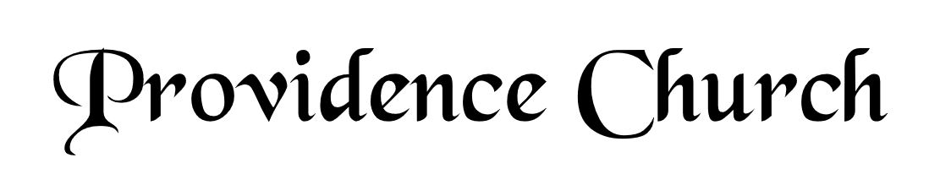
Welcome and Announcements
Silent Prayer

* Opening Praise Doxology
Praise God from whom all blessings flow
Praise him, all creatures here below
Praise him above, ye heavenly host
Praise Father, Son, and Holy Ghost. Amen.

* Call to Worship Psalm 100
Leader: Make a joyful noise to the Lord, all the lands!
People: Serve the Lord with gladness!
Leader: Come into His presence with singing!
People: Know that the Lord is God!
Leader: It is He that made us, and we are His,
People: We are His people and the sheep of His pasture.
Leader: Enter His gates with thanksgiving, and His courts with praise!
People: Give thanks to Him, bless His name!
* Prayer of Invocation

* Hymn
O Come, My Soul, Bless Thou the Lord #103E

Scriptural Exhortation Psalm 51:1-5

Prayer of Confession
O God our Father, You are holy and wise, and just and true in all Your ways. We confess we minimize You in our thoughts; our view of You is not high enough. We do not think of ourselves as ruined sinners before a completely just and holy God; all our sins condemn us. Dear Father, forgive us and pardon us through Christ’s atoning sacrifice. We thank You for what our Lord Jesus has done for us on the cross; cleansing us, purifying us before You. What a blessing to know we have been restored to You. May we live in Your strength day by day. Through Christ our Lord we pray, Amen.
Assurance of Pardon II Corinthians 5:17-21

* Hymn of Response
I Will Sing of My Redeemer #498

* Affirmation of Faith Westminster Larger Catechism
Q14. How doth God execute his decrees?
A14. God executeth his decrees in the works of creation and providence, according to his infallible foreknowledge, and the free and immutable counsel of his own will.

Q15. What is the work of creation?
A15. The work of creation is that wherein God did in the beginning, by the word of his power, make of nothing the world, and all things therein, for himself, within the space of six days, and all very good.

Q18. What are God’s works of providence?
A18. God’s works of providence are his most holy, wise, and powerful preserving and governing all his creatures; ordering them, and all their actions, to his own glory.

Prayer for the Covenant Community and Ruling Elder
The Lord’s Prayer Larry Watson
Our Father, Who art in heaven,
Hallowed be Thy name, Thy kingdom come,
Thy will be done, on earth as it is in heaven.
Give us this day our daily bread,
And forgive us our debts, as we forgive our debtors.
And lead us not into temptation,
But deliver us from evil,
For Thine is the kingdom, and the power,
And the glory forever, Amen.

Hymn
There Is a Fountain Filled with Blood #340

Sermon Text Psalm 37:1-7
Sermon And He Will Do It! Rev. Mark Wheat

* The Apostles’ Creed
I believe in God the Father Almighty,
Maker of heaven and earth.
I believe in Jesus Christ, his only Son, our Lord
Who was conceived by the Holy Spirit,
And born of the virgin Mary,
He suffered under Pontius Pilate,
Was crucified, died, and was buried.
He descended into hell.
The third day he rose again from the dead.
He ascended into heaven.
And is seated at the right hand of God the Father Almighty.
From there He will come to judge the living and the dead.
I believe in the Holy Spirit, the holy catholic church,
The communion of saints, the forgiveness of sins,
The resurrection of the body, and the life Everlasting.

* The Lord’s Supper

* Hymn
Great Is Thy Faithfulness #245

* Benediction
Nursery Volunteer Rotation
Sunday 4/19/2026  Dan & Shirley Wilkerson | Sunday 4/26/2026  Andrew & Regan van der Merwe

