11:00 am April 12, 2026
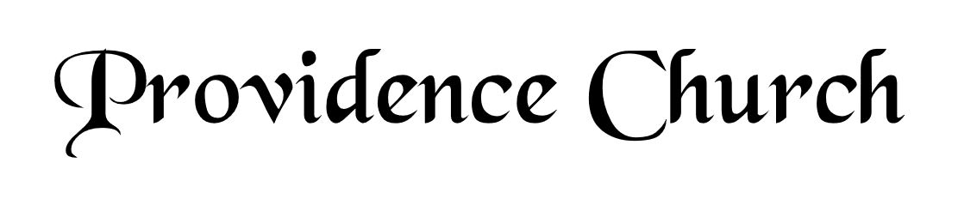
Welcome and Announcements
Silent Prayer

* Opening Praise Doxology
Praise God from whom all blessings flow
Praise him, all creatures here below
Praise him above, ye heavenly host
Praise Father, Son, and Holy Ghost. Amen.

* Call to Worship Psalm 121
Leader: I lift up my eyes to the hills.
People: From where does my help come?
Leader: My help comes from the LORD,
People: Who made heaven and earth.
Leader: Jesus Christ is Risen!
People: He is Risen indeed!
* Prayer of Invocation

* Hymn
O Word of God Incarnate #171

Scriptural Exhortation Romans 12:1-2

Prayer of Confession
Most merciful Father, Your plan for us is to know, serve, and magnify You through Jesus Christ. By Your great love, You have opened our eyes to new life in Him. We confess our devotion to You is still very weak. We follow the lusts and pleasures of worldliness too easily. Forgive us. Wash us clean; purify us by the atoning sacrifice of Jesus Christ at the cross. Make our chief desire to love and honor You above all. Help us to press ever upward in the call of Christ, in whose name we pray. Amen.
Assurance of Pardon Romans 8:1-2

* Hymn of Response
The God of Abraham Praise #234

* Affirmation of Faith Westminster Larger Catechism

Q1. What is the chief and highest end of man?
A1. Man’s chief and highest end is to glorify God, and fully to enjoy him forever.

Q2. How doth it appear that there is a God?
A2. The very light of nature in man, and the works of God, declare plainly that there is a God; but his word and Spirit only do sufficiently and effectually reveal him unto men for their salvation.

Q3. What is the Word of God?
A3. The Holy Scriptures of the Old and New Testament are the Word of God, the only rule of faith and obedience.

Prayer for the Covenant Community and Teaching Elder
The Lord’s Prayer Mark Wheat
Our Father, Who art in heaven,
Hallowed be Thy name, Thy kingdom come,
Thy will be done, on earth as it is in heaven.
Give us this day our daily bread,
And forgive us our debts, as we forgive our debtors.
And lead us not into temptation,
But deliver us from evil,
For Thine is the kingdom, and the power,
And the glory forever, Amen.
Hymn
And Can It Be That I Should Gain #431

Sermon Text Proverbs 4:20-27
Sermon Heart Work Rev. Mark Wheat

* The Apostles’ Creed
I believe in God the Father Almighty,
Maker of heaven and earth.
I believe in Jesus Christ, his only Son, our Lord
Who was conceived by the Holy Spirit,
And born of the virgin Mary,
He suffered under Pontius Pilate,
Was crucified, died, and was buried.
He descended into hell.
The third day he rose again from the dead.
He ascended into heaven.
And is seated at the right hand of God the Father Almighty.
From there He will come to judge the living and the dead.
I believe in the Holy Spirit, the holy catholic church,
The communion of saints, the forgiveness of sins,
The resurrection of the body, and the life Everlasting.

* Hymn
Like a River Glorious #485

* Benediction
Nursery Volunteer Rotation
Sunday 4/12/2026  Tim & Tessie West | Sunday 4/19/2026  Dan & Shirley Wilkerson

