11:00 am March 8, 2026
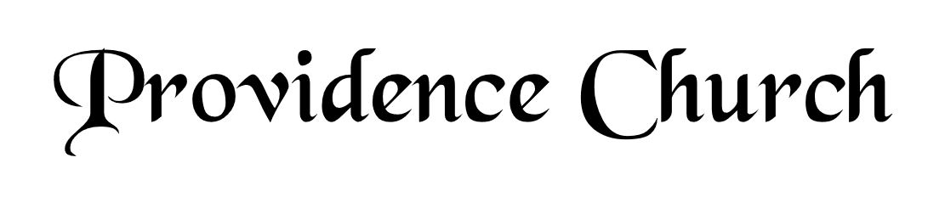
Welcome and Announcements
Silent Prayer

* Opening Praise Doxology
Praise God from whom all blessings flow
Praise him, all creatures here below
Praise him above, ye heavenly host
Praise Father, Son, and Holy Ghost. Amen.

* Call to Worship Psalm 149
Leader: Sing to the LORD a new song,
People: His praise in the assembly of the godly!
Leader: Let Israel be glad in his Maker;
People: let the children of Zion rejoice in their King!
Leader: Jesus Christ is risen!
People: He is risen indeed!
* Prayer of Invocation

* Hymn
Hear My Words, O LORD #5

Scriptural Exhortation Galatians 5:13-17

Prayer of Confession
O Lord God, eternal and almighty Father, we confess and acknowledge unfeignedly before thy holy majesty that we are poor sinners, conceived and born in iniquity and corruption, prone to do evil, incapable of any good, and that in our depravity we transgress thy holy commandments without end or ceasing: Wherefore we purchase for ourselves, through thy righteous judgment, our ruin and perdition. Nevertheless, O Lord, we are grieved that we have offended thee; and we condemn ourselves and our sins with true repentance, beseeching thy grace to relieve our distress. O God and Father most gracious and full of compassion, have mercy upon us in the name of thy Son, our Lord Jesus Christ. And as thou dost blot out our sins and stains, magnify and increase in us day by day the grace of thy Holy Spirit: that as we acknowledge our unrighteousness with all our heart, we may be moved by that sorrow which shall bring forth true repentance in us, mortifying all our sins, and producing in us the fruits of righteousness and innocence which are pleasing unto thee; through the same Jesus Christ Our Lord. Amen.
Assurance of Pardon Micah 7:18-19

* Hymn of Response
How Great Thou Art #227

* Affirmation of Faith Westminster Larger Catechism
Q. 183. For whom are we to pray?
A. We are to pray for the whole church of Christ upon earth; for magistrates, and ministers; for ourselves, our brethren, yea, our enemies; and for all sorts of men living, or that shall live hereafter; but not for the dead, nor for those that are known to have sinned the sin unto death.

Q. 184. For what things are we to pray?
A. We are to pray for all things tending to the glory of God, the welfare of the church, our own or others’ good; but not for anything that is unlawful.

Prayer of the Covenant Community and Ruling Elder
The Lord’s Prayer Larry Watson
Our Father, Who art in heaven,
Hallowed be Thy name, Thy kingdom come,
Thy will be done, on earth as it is in heaven.
Give us this day our daily bread,
And forgive us our debts, as we forgive our debtors.
And lead us not into temptation,
But deliver us from evil,
For Thine is the kingdom, and the power,
And the glory forever, Amen.

Hymn
Revive Thy Work, O Lord #413

Sermon Text Psalm 37:5-7
Sermon The Debtor and the Beggar Rev. Mark Wheat

* The Apostles’ Creed
I believe in God the Father Almighty,
Maker of heaven and earth.
I believe in Jesus Christ, his only Son, our Lord
Who was conceived by the Holy Spirit,
And born of the virgin Mary,
He suffered under Pontius Pilate,
Was crucified, died, and was buried.
He descended into hell.
The third day he rose again from the dead.
He ascended into heaven.
And is seated at the right hand of God the Father Almighty.
From there He will come to judge the living and the dead.
I believe in the Holy Spirit, the holy catholic church,
The communion of saints, the forgiveness of sins,
The resurrection of the body, and the life Everlasting.

* Hymn
It Is Well with My Soul #476

* Benediction
Nursery Volunteer Rotation
Sunday 3/8/2026  Andrew & Regan van der Merwe | Sunday 3/15/2026  Larry & Jennifer Watson

