11:00 am February 8, 2026
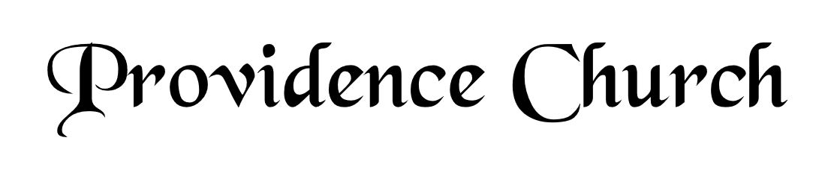
Welcome and Announcements
Silent Prayer

* Opening Praise Doxology
Praise God from whom all blessings flow
Praise him, all creatures here below
Praise him above, ye heavenly host
Praise Father, Son, and Holy Ghost. Amen.

* Call to Worship Psalm 66
Leader: Come and hear, all you who fear God.
People: And I will declare what He has done for my soul.
Leader: I cried to Him with my mouth.
People: And He was extolled with my tongue.
Leader: Jesus Christ is risen!
People: He is risen, indeed!
* Prayer of Invocation

* Hymn
The Lord’s My Shepherd #23A

Scriptural Exhortation Matthew 22:34-40

Prayer of Confession
Gracious Father, we confess that with Adam, from the Garden, we have broken Your covenant. We daily fall short of Your standard of holiness. Because of our sin, we condemn ourselves daily. We deserve eternal death. Yet, Father, we thank You for Your mercy. While in our sin, You promised and sent Your Son to bear our sins. He has kept the covenant for us. He has lived and died on our behalf. Because of Your Son, Jesus Christ, forgive us. We thank You for the eternal life accomplished by what He has done for us. Renew us to live in Your strength, to do Your will. Through Christ we pray. Amen.
Assurance of Pardon I John 1:8-9

* Hymn of Response
Praise to the Lord, the Almighty #216

* Affirmation of Faith Westminster Larger Catechism
Q156: Is the Word of God to be read by all?
A156: Although all are not to be permitted to read the word publicly to the congregation, yet all sorts of people are bound to read it apart by themselves, and with their families: to which end, the holy Scriptures are to be translated out of the original into vulgar languages.

Q157: How is the Word of God to be read?
A157: The holy Scriptures are to be read with an high and reverent esteem of them; with a firm persuasion that they are the very Word of God, and that he only can enable us to understand them; with desire to know, believe, and obey the will of God revealed in them; with diligence, and attention to the matter and scope of them; with meditation, application, self-denial, and prayer.

Prayer of the Covenant Community and Ruling Elder
The Lord’s Prayer Dan Wilkerson
Our Father, Who art in heaven,
Hallowed be Thy name, Thy kingdom come,
Thy will be done, on earth as it is in heaven.
Give us this day our daily bread,
And forgive us our debts, as we forgive our debtors.
And lead us not into temptation,
But deliver us from evil,
For Thine is the kingdom, and the power,
And the glory forever, Amen.

Hymn
Glorious Things of Thee Are Spoken #403

Sermon Text Psalm 37:1-3
Sermon What is God Saying to Us? Rev. Mark Wheat

* The Apostles’ Creed
I believe in God the Father Almighty,
Maker of heaven and earth.
I believe in Jesus Christ, his only Son, our Lord
Who was conceived by the Holy Spirit,
And born of the virgin Mary,
He suffered under Pontius Pilate,
Was crucified, died, and was buried.
He descended into hell.
The third day he rose again from the dead.
He ascended into heaven.
And is seated at the right hand of God the Father Almighty.
From there He will come to judge the living and the dead.
I believe in the Holy Spirit, the holy catholic church,
The communion of saints, the forgiveness of sins,
The resurrection of the body, and the life Everlasting.

* Hymn
Savior, like a Shepherd Lead Us #525

* Benediction
Nursery Volunteer Rotation
Sunday 2/8/2026  Maurice & Carolyn Carlson | Sunday 2/15/2026  Dan & Kate Wilkerson

