11:00 am February 22, 2026
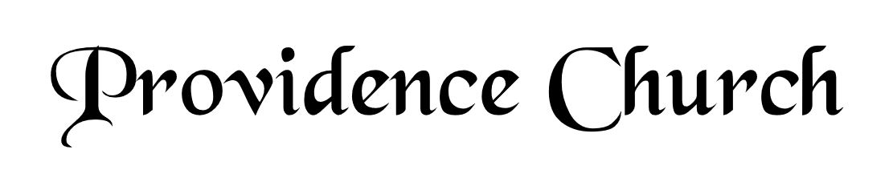
Welcome and Announcements
Silent Prayer

* Opening Praise Doxology
Praise God from whom all blessings flow
Praise him, all creatures here below
Praise him above, ye heavenly host
Praise Father, Son, and Holy Ghost. Amen.

* Call to Worship Psalm 96
Leader: Ascribe to the Lord, O families of the peoples,
People: Ascribe to the Lord glory and strength!
Leader: Ascribe to the Lord the glory due His name;
People: Bring an offering and come into His courts!
Leader: Worship the Lord in holy array;
People: Tremble before Him all the earth!
* Prayer of Invocation

* Hymn
The Lord’s My Shepherd #23A

Scriptural Exhortation Romans 12:1-2

Prayer of Confession
Almighty God, we confess this morning that by nature and practice we are sinners, for this is what Your Word teaches. We ask that as You showed mercy to the publican, that You would show mercy to us as well. Father, we abhor our indolence, envy, meanness, and pride. We ask that You would forgive and kill these vices in us. Have mercy on our unbelief and upon our corrupt and often wandering hearts. Forgive us for setting our affections on the things of the world. Grant that we would daily take refuge in that fountain that cleanses us from all sin. This we ask in Jesus’ name, Amen.
Assurance of Pardon Psalm 130:3-4

* Hymn of Response
O God, Our Help in Ages Past #222

* Affirmation of Faith Westminster Larger Catechism
Q77. Wherein do justification and sanctification differ?
A77. Although sanctification be inseparably joined with justification, yet they differ, in that God in justification imputeth the righteousness of Christ; in sanctification his Spirit infuseth grace, and enableth to the exercise thereof; in the former, sin is pardoned; in the other, it is subdued: the one doth equally free all believers from the revenging wrath of God, and that perfectly in this life, that they never fall into condemnation; the other is neither equal in all, nor in this life perfect in any, but growing up to perfection.

Q78. Whence ariseth the imperfection of sanctification in believers?
A78. The imperfection of sanctification in believers ariseth from the remnants of sin abiding in every part of them, and the perpetual lustings of the flesh against the spirit; whereby they are often foiled with temptations, and fall into many sins, are hindered in all their spiritual services, and their best works are imperfect and defiled in the sight of God.

Prayer of the Covenant Community and Ruling Elder
The Lord’s Prayer Glenn Dowling
Our Father, Who art in heaven,
Hallowed be Thy name, Thy kingdom come,
Thy will be done, on earth as it is in heaven.
Give us this day our daily bread,
And forgive us our debts, as we forgive our debtors.
And lead us not into temptation,
But deliver us from evil,
For Thine is the kingdom, and the power,
And the glory forever, Amen.

Hymn
Jesus, with Thy Church Abide #406

Sermon Text Psalm 37:1-4
Sermon Trust in the Lord and Do Good Rev. Mark Wheat

* The Apostles’ Creed
I believe in God the Father Almighty,
Maker of heaven and earth.
I believe in Jesus Christ, his only Son, our Lord
Who was conceived by the Holy Spirit,
And born of the virgin Mary,
He suffered under Pontius Pilate,
Was crucified, died, and was buried.
He descended into hell.
The third day he rose again from the dead.
He ascended into heaven.
And is seated at the right hand of God the Father Almighty.
From there He will come to judge the living and the dead.
I believe in the Holy Spirit, the holy catholic church,
The communion of saints, the forgiveness of sins,
The resurrection of the body, and the life Everlasting.

* Hymn
Love Divine, All Loves Excelling #465

* Benediction
Nursery Volunteer Rotation
Sunday 2/22/2026  Tim & Tessie West | Sunday 3/1/2026  Dan & Kate Wilkerson

