11:00 am January 4, 2026
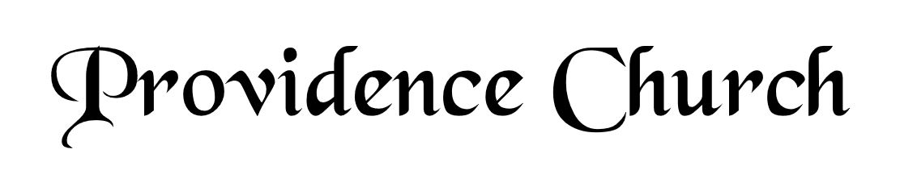
Prelude
Welcome and Announcements
Silent Prayer

* Opening Praise Doxology
Praise God from whom all blessings flow
Praise him, all creatures here below
Praise him above, ye heavenly host
Praise Father, Son, and Holy Ghost. Amen.

* Call to Worship Isaiah 55
Leader: Seek the LORD while He may be found.
People: Call upon Him while He is near.
Leader: Let the wicked forsake his way, and the unrighteous man his thoughts.
People: Let him return to the LORD, that He may have compassion on him.
Leader: Jesus Christ is risen!
People: He is risen indeed!
* Prayer of Invocation

* Hymn
Wholehearted Thanksgiving #9B

Scriptural Exhortation Psalm 25:8-10

Prayer of Confession
Almighty Father, we enter your presence confessing the things we try to conceal from you and the things we try to conceal from others. We confess the heartbreak, worry, and sorrow we have caused, that make it difficult for others to forgive us, the times we have made it easy for others to do wrong, and the harm we have done that makes it hard for us to forgive ourselves. Lord have mercy and forgive us through Christ. Amen.
Assurance of Pardon Psalm 130:1-4

* Hymn of Response
O Word of God Incarnate #171

* Affirmation of Faith Westminster Confession of Faith
Chapter 21: Of Religious Worship, and the Sabbath Day
Article 1 and 2
1. The light of nature showeth that there is a God, who hath lordship and sovereignty over all, is good, and doth good unto all, and is therefore to be feared, loved, praised, called upon, trusted in, and served, with all the heart, and with all the soul, and with all the might. But the acceptable way of worshiping the true God is instituted by himself, and so limited by his own revealed will, that he may not be worshiped according to the imaginations and devices of men, or the suggestions of Satan, under any visible representation, or any other way not prescribed in the Holy Scripture.

2. Religious worship is to be given to God, the Father, Son, and Holy Ghost; and to him alone; not to angels, saints, or any other creature: and, since the fall, not without a Mediator; nor in the mediation of any other but of Christ alone.

Prayer of the Congregation and Ruling Elder
The Lord’s Prayer Dan Wilkerson
Our Father, Who art in heaven,
Hallowed be Thy name, Thy kingdom come,
Thy will be done, on earth as it is in heaven.
Give us this day our daily bread,
And forgive us our debts, as we forgive our debtors.
And lead us not into temptation,
But deliver us from evil,
For Thine is the kingdom, and the power,
And the glory forever, Amen.

Hymn
Breathe on Me, Breath of God #397

Sermon Text Psalm 84:1-4
Sermon Longing for Public Worship Rev. Mark Wheat

* The Nicene Creed
We believe in one God, the Father Almighty, Maker of heaven and earth, of all things visible and invisible.
And in one Lord Jesus Christ, the only-begotten Son of God, begotten of his Father before all worlds, God of God, Light of Light, very God of very God, begotten, not made, being of one substance with the Father; by whom all things were made; who for us and for our salvation came down from heaven, and was incarnate by the Holy Spirit of the virgin Mary, and was made man; and was crucified also for us under Pontius Pilate; he suffered and was buried; and the third day he rose again according to the Scriptures, and ascended into heaven, and is seated at the right hand of the Father; and he shall come again, with glory, to judge both the living and the dead; whose kingdom shall have no end.
And we believe in the Holy Spirit, the Lord and giver of life, who proceeds from the Father and the Son; who with the Father and the Son together is worshiped and glorified; who spoke by the prophets; and we believe in one holy catholic and apostolic church; we acknowledge one baptism for the remission of sins; and we look for the resurrection of the dead, and of the life of the world to come. Amen.

* Hymn
God Be with You Till We Meet Again #207

* Benediction
Nursery Volunteer Rotation
Sunday 1/4/2025  Tim & Tessie West | Sunday 1/11/2025  Dan & Shirley Wilkerson

