11:00 am January 11, 2026
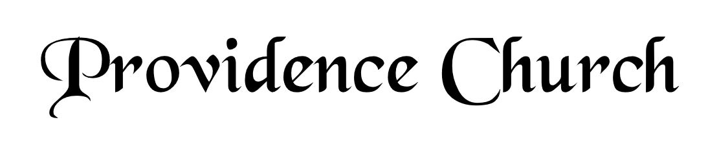
Prelude
Welcome and Announcements
Silent Prayer

* Opening Praise Doxology
Praise God from whom all blessings flow
Praise him, all creatures here below
Praise him above, ye heavenly host
Praise Father, Son, and Holy Ghost. Amen.

* Call to Worship Isaiah 12
Leader: Give thanks to the LORD, call upon His name!
People: Make known His deeds among the peoples, proclaim that His name is exalted.
Leader: Sing praises to the LORD!
People: For He has done gloriously!
Leader: Jesus Christ is risen!
People: He is risen, indeed!
* Prayer of Invocation

* Hymn
Wholehearted Thanksgiving #9B

Scriptural Exhortation Proverbs 28:13

Prayer of Confession
God of grace and truth, in Jesus Christ you came among us as light shining in darkness, bringing the good news of joy that mankind is reconciled to God through Jesus. We confess that we have not welcomed the light or trusted the good news. We have closed our eyes to your glory in our midst, and have ignored your presence in the Spirit of our Lord Jesus Christ. And, barely acknowledging in our lives Jesus’ first coming, we have not watched diligently for the final coming of our Savior and Judge. Forgive our sin, and renew our hope in the gospel, so that we may receive the fullness of your grace, and live in the truth of Christ our Lord, in whose name we pray. Amen.
Assurance of Pardon I John 1:8-9

* Hymn of Response
Now Thank We All Our God #181

* Affirmation of Faith Westminster Confession of Faith
Chapter 21: Of Religious Worship, and the Sabbath Day
Articles 3 & 4
3. Prayer, with thanksgiving, being one special part of religious worship, is by God required of all men: and, that it may be accepted, it is to be made in the name of the Son, by the help of his Spirit, according to his will, with understanding, reverence, humility, fervency, faith, love, and perseverance; and, if vocal, in a known tongue.

4. Prayer is to be made for things lawful; and for all sorts of men living, or that shall live hereafter: but not for the dead, nor for those of whom it may be known that they have sinned the sin unto death.

Prayer of the Congregation and Ruling Elder
The Lord’s Prayer Norval Sells
Our Father, Who art in heaven,
Hallowed be Thy name, Thy kingdom come,
Thy will be done, on earth as it is in heaven.
Give us this day our daily bread,
And forgive us our debts, as we forgive our debtors.
And lead us not into temptation,
But deliver us from evil,
For Thine is the kingdom, and the power,
And the glory forever, Amen.

Hymn
The Church’s One Foundation #404

Sermon Text Psalm 84:1-7
Sermon Planning a Pilgrimage Rev. Mark Wheat

* The Nicene Creed
We believe in one God, the Father Almighty, Maker of heaven and earth, of all things visible and invisible.
And in one Lord Jesus Christ, the only-begotten Son of God, begotten of his Father before all worlds, God of God, Light of Light, very God of very God, begotten, not made, being of one substance with the Father; by whom all things were made; who for us and for our salvation came down from heaven, and was incarnate by the Holy Spirit of the virgin Mary, and was made man; and was crucified also for us under Pontius Pilate; he suffered and was buried; and the third day he rose again according to the Scriptures, and ascended into heaven, and is seated at the right hand of the Father; and he shall come again, with glory, to judge both the living and the dead; whose kingdom shall have no end.
And we believe in the Holy Spirit, the Lord and giver of life, who proceeds from the Father and the Son; who with the Father and the Son together is worshiped and glorified; who spoke by the prophets; and we believe in one holy catholic and apostolic church; we acknowledge one baptism for the remission of sins; and we look for the resurrection of the dead, and of the life of the world to come. Amen.

* Hymn
Come, Thou Almighty King #212

* Benediction
Nursery Volunteer Rotation
Sunday 1/11/2025  Dan & Shirley Wilkerson | Sunday 1/18/2025  Andrew & Regan van der Merwe

