11:00 am December 28, 2025
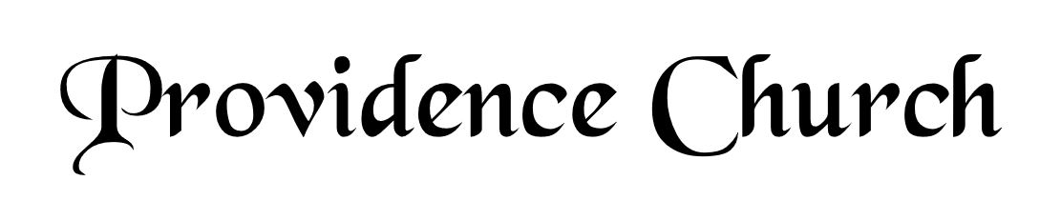
Prelude
Welcome and Announcements
Silent Prayer

* Opening Praise Doxology
Praise God from whom all blessings flow
Praise him, all creatures here below
Praise him above, ye heavenly host
Praise Father, Son, and Holy Ghost. Amen.

* Call to Worship Psalm 105
Leader: O give thanks to the LORD; call upon His name.
People: Make known His deeds among the peoples!
Leader: Sing to Him, sing praises to Him.
People: Tell of all His wondrous works!
Leader: Jesus Christ is risen!
People: He is risen indeed!
* Prayer of Invocation

* Hymn
Why Do Heathen Nations Rage? #2A

Scriptural Exhortation Matthew 22:34-40

Prayer of Confession
Almighty God, since thou delayst with so much forbearance the punishments which we have deserved and daily draw on ourselves, grant that we may not indulge ourselves but carefully consider how often and in how many different ways we have provoked thy wrath against us. May we learn humbly to present ourselves to thee for pardon, and with true repentance implore thy mercy. With all our heart we desire to submit ourselves to thee, whether thou chastises us, or according to thine infinite goodness, or forgives us. Let our condition be ever blessed, not by flattering ourselves in our apathy, but by finding thee to be our kind and bountiful Father, reconciled to us in thine only-begotten Son. Amen.
Assurance of Pardon Romans 5:8-10

* Hymn of Response
Silent Night! Holy Night! #315

* Affirmation of Faith Westminster Confession of Faith
Chapter 8: Of Christ the Mediator
5. The Lord Jesus, by his perfect obedience, and sacrifice of himself, which he, through the eternal Spirit, once offered up unto God, hath fully satisfied the justice of his Father; and purchased, not only reconciliation, but an everlasting inheritance in the kingdom of heaven, for all those whom the Father hath given unto him.

6. Although the work of redemption was not actually wrought by Christ till after his incarnation, yet the virtue, efficacy, and benefits thereof were communicated unto the elect, in all ages successively from the beginning of the world, in and by those promises, types, and sacrifices, wherein he was revealed, and signified to be the seed of the woman which should bruise the serpent’s head; and the Lamb slain from the beginning of the world; being yesterday and today the same, and forever.

Prayer of the Congregation and Ruling Elder
The Lord’s Prayer Larry Watson
Our Father, Who art in heaven,
Hallowed be Thy name, Thy kingdom come,
Thy will be done, on earth as it is in heaven.
Give us this day our daily bread,
And forgive us our debts, as we forgive our debtors.
And lead us not into temptation,
But deliver us from evil,
For Thine is the kingdom, and the power,
And the glory forever, Amen.

Hymn
What Child Is This #317

Sermon Text Luke 2:21-32
Sermon Simeon's Song Rev. Mark Wheat

* The Apostles’ Creed
I believe in God the Father Almighty,
Maker of heaven and earth.
I believe in Jesus Christ, his only Son, our Lord
Who was conceived by the Holy Spirit,
And born of the virgin Mary,
He suffered under Pontius Pilate,
Was crucified, died, and was buried.
He descended into hell.
The third day he rose again from the dead.
He ascended into heaven.
And is seated at the right hand of God the Father Almighty.
From there He will come to judge the living and the dead.
I believe in the Holy Spirit, the holy catholic church,
The communion of saints, the forgiveness of sins,
The resurrection of the body, and the life Everlasting.

* Hymn
O Come, All Ye Faithful #319

* Benediction
Nursery Volunteer Rotation
Sunday 12/28/2025  Dan & Kate Wilkerson | Sunday 1/4/2025  Tim & Tessie West

