11:00 am December 14, 2025
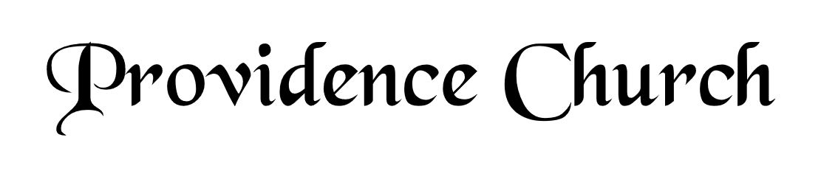
Prelude
Welcome and Announcements
Silent Prayer

* Opening Praise Doxology
Praise God from whom all blessings flow
Praise him, all creatures here below
Praise him above, ye heavenly host
Praise Father, Son, and Holy Ghost. Amen.

* Call to Worship Psalm 33
Leader: Shout for joy in the LORD, O you righteous!
People: Praise befits the upright. Give thanks to the LORD with the lyre.
Leader: Make melody to Him with the harp of ten strings.
People: Sing to Him a new song; play skillfully on the strings, with loud shouts.
Leader: Jesus Christ Is Risen!
People: He Is Risen Indeed!
* Prayer of Invocation

* Hymn
Why Do Heathen Nations Rage? #2A

Scriptural Exhortation Psalm 1:1-3

Prayer of Confession
Almighty and most merciful Father, we have erred and strayed from Your ways like lost sheep. We have followed too much the devices and desires of our own hearts. We have offended against Your holy laws. We have left undone those things which we ought to have done; and we have done those things which we ought not to have done; and there is nothing good in us. O Lord, have mercy upon us, miserable offenders. Spare those, O God, who confess their faults. Restore those who are penitent; according to Your promises declared unto men in Christ Jesus our Lord. Grant that we may hereafter live a godly, righteous, and sober life; to the glory of His name. Amen.
Assurance of Pardon Romans 5:8-10

* Hymn of Response
All My Heart This Night Rejoices #307

* Affirmation of Faith Westminster Confession of Faith
Chapter 8: Of Christ the Mediator
1. It pleased God, in his eternal purpose, to choose and ordain the Lord Jesus, his only begotten Son, to be the Mediator between God and man, the Prophet, Priest, and King, the Head and Savior of his church, the Heir of all things, and Judge of the world: unto whom he did from all eternity give a people, to be his seed, and to be by him in time redeemed, called, justified, sanctified, and glorified.

2. The Son of God, the second person in the Trinity, being very and eternal God, of one substance and equal with the Father, did, when the fullness of time was come, take upon him man’s nature, with all the essential properties, and common infirmities thereof, yet without sin; being conceived by the power of the Holy Ghost, in the womb of the virgin Mary, of her substance. So that two whole, perfect, and distinct natures, the Godhead and the manhood, were inseparably joined together in one person, without conversion, composition, or confusion. Which person is very God, and very man, yet one Christ, the only Mediator between God and man.

Prayer of the Congregation and Ruling Elder
The Lord’s Prayer Norval Sells
Our Father, Who art in heaven,
Hallowed be Thy name, Thy kingdom come,
Thy will be done, on earth as it is in heaven.
Give us this day our daily bread,
And forgive us our debts, as we forgive our debtors.
And lead us not into temptation,
But deliver us from evil,
For Thine is the kingdom, and the power,
And the glory forever, Amen.

Hymn
Good Christian Men, Rejoice #308

Sermon Text Luke 1:67-80
Sermon Zechariah’s Song Rev. Mark Wheat

* The Apostles’ Creed
I believe in God the Father Almighty,
Maker of heaven and earth.
I believe in Jesus Christ, his only Son, our Lord
Who was conceived by the Holy Spirit,
And born of the virgin Mary,
He suffered under Pontius Pilate,
Was crucified, died, and was buried.
He descended into hell.
The third day he rose again from the dead.
He ascended into heaven.
And is seated at the right hand of God the Father Almighty.
From there He will come to judge the living and the dead.
I believe in the Holy Spirit, the holy catholic church,
The communion of saints, the forgiveness of sins,
The resurrection of the body, and the life Everlasting.

* Hymn
While Shepherds Watched Their Flocks #310

* Benediction
Nursery Volunteer Rotation
Sunday 12/14/2025  Larry & Jennifer Watson | Sunday 12/21/2025  Maurice & Carolyn Carlson

