11:00 am November 9, 2025
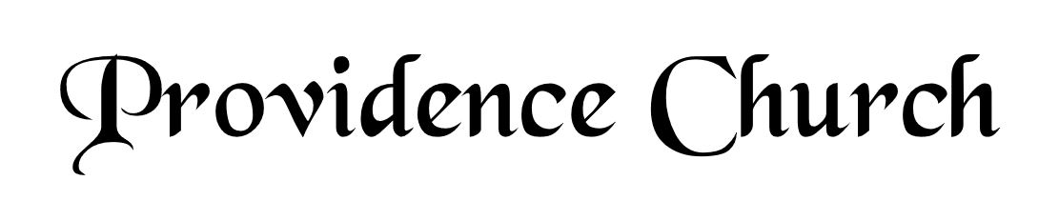
Prelude
Welcome and Announcements
Silent Prayer

* Opening Praise Doxology
Praise God from whom all blessings flow
Praise him, all creatures here below
Praise him above, ye heavenly host
Praise Father, Son, and Holy Ghost. Amen.

* Call to Worship Psalm 100
Leader: Make a joyful noise to the Lord, all the lands!
People: Serve the Lord with gladness!
Leader: Come into His presence with singing!
People: Know that the Lord is God!
Leader: It is He that made us, and we are His,
People: We are His people and the sheep of His pasture.
Leader: Enter His gates with thanksgiving, and His courts with praise!
People: Give thanks to Him, bless His name!
* Prayer of Invocation

* Hymn
I Will Extol You, O My God #145C

Scriptural Exhortation Hebrews 12:1-2

Prayer of Confession
Gracious Father, You have shown us in Your Word how we are to glorify You – by living according to Your Word. However, we have often gone our own way. We have not lived using the Scriptures as the only rule to direct us. We have sought our own wisdom and the wisdom of the world. Forgive us and cleanse us by the shed blood of Christ. Help us to use Your Word. Help us to seek You in it, that we might glorify and enjoy You. In Christ’s name we pray. Amen.
Assurance of Pardon Psalm 130:3-4

* Hymn of Response
Holy, Holy, Holy! #230

* Affirmation of Faith Heidelberg Catechism
Q1: What is your only comfort in life and in death?
A1: That I am not my own, but belong—body and soul, in life and in death—to my faithful Savior, Jesus Christ. He has fully paid for all my sins with his precious blood, and has set me free from the tyranny of the devil. He also watches over me in such a way that not a hair can fall from my head without the will of my Father in heaven; in fact, all things must work together for my salvation. Because I belong to him, Christ, by his Holy Spirit, assures me of eternal life and makes me wholeheartedly willing and ready from now on to live for him.

Prayer of the Congregation and Ruling Elder
The Lord’s Prayer Dan Wilkerson
Our Father, Who art in heaven,
Hallowed be Thy name, Thy kingdom come,
Thy will be done, on earth as it is in heaven.
Give us this day our daily bread,
And forgive us our debts, as we forgive our debtors.
And lead us not into temptation,
But deliver us from evil,
For Thine is the kingdom, and the power,
And the glory forever, Amen.

Hymn
I Love to Tell the Story #438

Sermon Text Proverbs 24:11-12, 11:30 & James 5:20
Sermon Is Soul-Winning a Bible Truth? Rev. Bill Fitzhenry

* The Apostles’ Creed
I believe in God the Father Almighty,
Maker of heaven and earth.
I believe in Jesus Christ, his only Son, our Lord
Who was conceived by the Holy Spirit,
And born of the virgin Mary,
He suffered under Pontius Pilate,
Was crucified, died, and was buried.
He descended into hell.
The third day he rose again from the dead.
He ascended into heaven.
And is seated at the right hand of God the Father Almighty.
From there He will come to judge the living and the dead.
I believe in the Holy Spirit, the holy catholic church,
The communion of saints, the forgiveness of sins,
The resurrection of the body, and the life Everlasting.

* Hymn
I Know Whom I Have Believed #517

* Benediction
Nursery Volunteer Rotation
Sunday 11/9/2025  Maurice & Carolyn Carlson | Sunday 11/16/2025  Dan & Kate Wilkerson

