11:00 am November 30, 2025
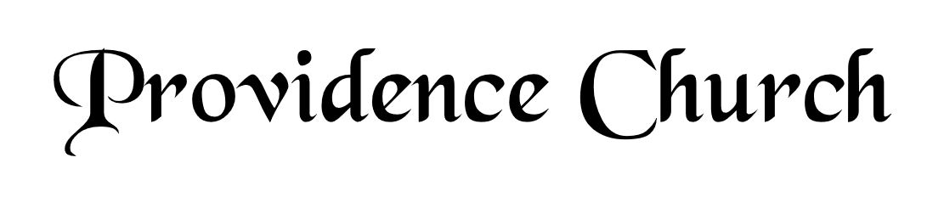
Prelude
Welcome and Announcements
Silent Prayer

* Opening Praise Doxology
Praise God from whom all blessings flow
Praise him, all creatures here below
Praise him above, ye heavenly host
Praise Father, Son, and Holy Ghost. Amen.

* Call to Worship Psalm 66
Leader: Come and hear, all you who fear God.
People: And I will declare what He has done for my soul.
Leader: I cried to Him with my mouth.
People: And He was extolled with my tongue.
Leader: Jesus Christ is risen!
People: He is risen indeed!
* Prayer of Invocation

* Hymn
Shout to the LORD, All Earth #100A

Scriptural Exhortation Psalm 25:4-8

Prayer of Confession
Dear Heavenly Father, You have made me for Your glory and service. I know my life belongs to You, but I live as if it were mine to do with as I please. I have been self-serving. I have boasted in myself and my accomplishments. Take away my sins through Christ’s shed blood, and renew me with an undivided heart. Fill me with Your Holy Spirit. Help me to serve You in faithfulness with my time, talents, relationships, health, and finances in every area of my life. Through Christ I pray. Amen.
Assurance of Pardon Romans 5:8-10

* Hymn of Response
O Come, O Come, Emmanuel #293

* Affirmation of Faith Westminster Larger Catechism
Q75: What is sanctification?
A75: Sanctification is a work of God’s grace, whereby they whom God hath, before the foundation of the world, chosen to be holy, are in time, through the powerful operation of his Spirit applying the death and resurrection of Christ unto them, renewed in their whole man after the image of God; having the seeds of repentance unto life, and all other saving graces, put into their hearts, and those graces so stirred up, increased, and strengthened, as that they more and more die unto sin, and rise unto newness of life.

Q79: May not true believers, by reason of their imperfections, and the many temptations and sins they are overtaken with, fall away from the state of grace?
A79: True believers, by reason of the unchangeable love of God, and his decree and covenant to give them perseverance, their inseparable union with Christ, his continual intercession for them, and the Spirit and seed of God abiding in them, can neither totally nor finally fall away from the state of grace, but are kept by the power of God through faith unto salvation.

Prayer of the Congregation and Ruling Elder
The Lord’s Prayer Larry Watson
Our Father, Who art in heaven,
Hallowed be Thy name, Thy kingdom come,
Thy will be done, on earth as it is in heaven.
Give us this day our daily bread,
And forgive us our debts, as we forgive our debtors.
And lead us not into temptation,
But deliver us from evil,
For Thine is the kingdom, and the power,
And the glory forever, Amen.

Hymn
My Faith Looks Up to Thee #466

Sermon Text I Peter 1:3-9
Sermon Know Pain; Know Gain Rev. David Boxerman

* The Apostles’ Creed
I believe in God the Father Almighty,
Maker of heaven and earth.
I believe in Jesus Christ, his only Son, our Lord
Who was conceived by the Holy Spirit,
And born of the virgin Mary,
He suffered under Pontius Pilate,
Was crucified, died, and was buried.
He descended into hell.
The third day he rose again from the dead.
He ascended into heaven.
And is seated at the right hand of God the Father Almighty.
From there He will come to judge the living and the dead.
I believe in the Holy Spirit, the holy catholic church,
The communion of saints, the forgiveness of sins,
The resurrection of the body, and the life Everlasting.

* Hymn
Why Should Cross and Trial Grieve Me? #509

* Benediction
Nursery Volunteer Rotation
Sunday 11/30/2025  Dan & Shirley Wilkerson | Sunday 12/7/2025  Andrew & Regan van der Merwe

