11:00 am November 23, 2025
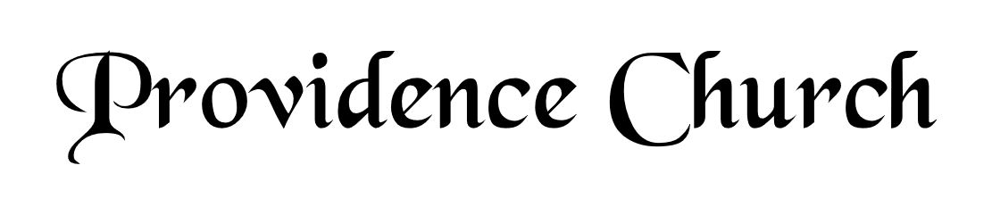
Prelude
Welcome and Announcements
Silent Prayer

* Opening Praise Doxology
Praise God from whom all blessings flow
Praise him, all creatures here below
Praise him above, ye heavenly host
Praise Father, Son, and Holy Ghost. Amen.

* Call to Worship Isaiah 53
Leader: Therefore, I will divide him a portion with the great,
People: And he shall divide the spoil with the strong;
Leader: Because he poured out his soul to death,
People: And was numbered with the transgressors;
Leader: Yet he bore the sin of many,
People: And made intercession for the transgressors.
Leader: Jesus Christ is risen!
People: He is risen indeed!
* Prayer of Invocation

* Hymn
Shout to the LORD, All Earth #100A

Scriptural Exhortation Psalm 51:1-5

Prayer of Confession
O God our Father, You are holy and wise, and just and true in all Your ways. We confess we minimize You in our thoughts;
our view of You is not high enough. We do not think of ourselves as ruined sinners before a completely just and holy God; all our sins condemn us. Dear Father, forgive us and pardon us through Christ’s atoning sacrifice. We thank You for what our Lord Jesus has done for us on the cross; cleansing us, purifying us before You. What a blessing to know we have been restored to You. May we live in Your strength day by day. Through Christ our Lord we pray, Amen.
Assurance of Pardon II Corinthians 5:17-21

* Hymn of Response
Love Divine, All Loves Excelling #465

* Affirmation of Faith Westminster Larger Catechism
Q90: What shall be done to the righteous at the day of judgment?
A90: At the day of judgment, the righteous, being caught up to Christ in the clouds, shall be set on his right hand, and there openly acknowledged and acquitted, shall join with him in the judging of reprobate angels and men, and shall be received into heaven, where they shall be fully and forever freed from all sin and misery; filled with inconceivable joys, made perfectly holy and happy both in body and soul, in the company of innumerable saints and holy angels, but especially in the immediate vision and fruition of God the Father, of our Lord Jesus Christ, and of the Holy Spirit, to all eternity. And this is the perfect and full communion which the members of the invisible church shall enjoy with Christ in glory, at the resurrection and day of judgment.

Prayer of the Congregation and Ruling Elder
The Lord’s Prayer Glenn Dowling
Our Father, Who art in heaven,
Hallowed be Thy name, Thy kingdom come,
Thy will be done, on earth as it is in heaven.
Give us this day our daily bread,
And forgive us our debts, as we forgive our debtors.
And lead us not into temptation,
But deliver us from evil,
For Thine is the kingdom, and the power,
And the glory forever, Amen.

Hymn
I Know Whom I Have Believed #517

Sermon Text I Peter 1:3-6
Sermon What We’ve Got Is Quite A Lot Rev. David Boxerman

* The Apostles’ Creed
I believe in God the Father Almighty,
Maker of heaven and earth.
I believe in Jesus Christ, his only Son, our Lord
Who was conceived by the Holy Spirit,
And born of the virgin Mary,
He suffered under Pontius Pilate,
Was crucified, died, and was buried.
He descended into hell.
The third day he rose again from the dead.
He ascended into heaven.
And is seated at the right hand of God the Father Almighty.
From there He will come to judge the living and the dead.
I believe in the Holy Spirit, the holy catholic church,
The communion of saints, the forgiveness of sins,
The resurrection of the body, and the life Everlasting.

* Hymn
Come, Ye Thankful People, Come #552

* Benediction
Nursery Volunteer Rotation
Sunday 11/23/2025  Tim & Tessie West | Sunday 11/30/2025  Dan & Shirley Wilkerson

