11:00 am November 2, 2025
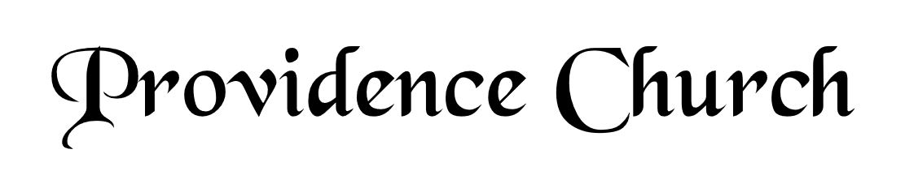
Prelude
Welcome and Announcements
Silent Prayer

* Opening Praise Doxology
Praise God from whom all blessings flow
Praise him, all creatures here below
Praise him above, ye heavenly host
Praise Father, Son, and Holy Ghost. Amen.

* Call to Worship Psalm 121
Leader: I Lift up my eyes to the hills.
People: From where does my help come?
Leader: My help comes from the LORD,
People: Who made heaven and earth.
Leader: Jesus Christ is Risen!
People: He is Risen indeed!
* Prayer of Invocation

* Hymn
I Will Extol You, O My God #145C

Scriptural Exhortation Colossians 3:5-10

Prayer of Confession
Holy Father, we come before You in the righteousness of Christ, through whom we've been forgiven and justified, and we are thankful. We acknowledge Your claim on us: that we pursue righteousness—holy and obedient living that is blameless before God and man. How far we have fallen short in this. We confess that we have not pursued it with all our strength. We have not hated sin and loved righteousness, often doing the opposite instead. Please forgive our lukewarmness toward godly living. Wash us in the blood of our righteous Substitute, that we might die to sin and live to righteousness. For Jesus' sake we pray. Amen.
Assurance of Pardon I John 1:8-9

* Hymn of Response
’Tis Not That I Did Choose Thee #428

* Affirmation of Faith Westminster Confession of Faith
Chapter 3 Paragraph 5:
Those of mankind that are predestinated unto life, God, before the foundation of the world was laid, according to his eternal and immutable purpose, and the secret counsel and good pleasure of his will, hath chosen, in Christ, unto everlasting glory, out of his mere free grace and love, without any foresight of faith, or good works, or perseverance in either of them, or any other thing in the creature, as conditions, or causes moving him thereunto; and all to the praise of his glorious grace.

Chapter 3 Paragraph 6:
As God hath appointed the elect unto glory, so hath he, by the eternal and most free purpose of his will, foreordained all the means thereunto. Wherefore, they who are elected, being fallen in Adam, are redeemed by Christ, are effectually called unto faith in Christ by his Spirit working in due season, are justified, adopted, sanctified, and kept by his power, through faith, unto salvation. Neither are any other redeemed by Christ, effectually called, justified, adopted, sanctified, and saved, but the elect only.

Chapter 3 Paragraph 8:
The doctrine of this high mystery of predestination is to be handled with special prudence and care, that men, attending the will of God revealed in his Word, and yielding obedience thereunto, may, from the certainty of their effectual vocation, be assured of their eternal election. So shall this doctrine afford matter of praise, reverence, and admiration of God; and of humility, diligence, and abundant consolation to all that sincerely obey the gospel.

Prayer of the Congregation and Ruling Elder
The Lord’s Prayer Larry Watson
Our Father, Who art in heaven,
Hallowed be Thy name, Thy kingdom come,
Thy will be done, on earth as it is in heaven.
Give us this day our daily bread,
And forgive us our debts, as we forgive our debtors.
And lead us not into temptation,
But deliver us from evil,
For Thine is the kingdom, and the power,
And the glory forever, Amen.

Hymn
Come, Thou Fount of Every Blessing #429

Sermon Text I Peter 1:1-2
Sermon The Only Election That Matters Rev. David Boxerman

* The Apostles’ Creed
I believe in God the Father Almighty,
Maker of heaven and earth.
I believe in Jesus Christ, his only Son, our Lord
Who was conceived by the Holy Spirit,
And born of the virgin Mary,
He suffered under Pontius Pilate,
Was crucified, died, and was buried.
He descended into hell.
The third day he rose again from the dead.
He ascended into heaven.
And is seated at the right hand of God the Father Almighty.
From there He will come to judge the living and the dead.
I believe in the Holy Spirit, the holy catholic church,
The communion of saints, the forgiveness of sins,
The resurrection of the body, and the life Everlasting.

* Hymn
And Can It Be That I Should Gain #431

* Benediction
Nursery Volunteer Rotation
Sunday 11/2/2025  Larry & Jennifer Watson | Sunday 11/9/2025  Maurice & Carolyn Carlson

