11:00 am November 16, 2025
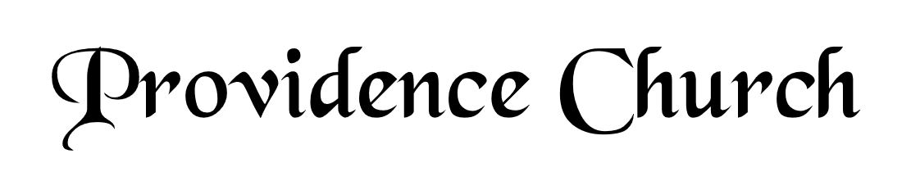
Prelude
Welcome and Announcements
Silent Prayer

* Opening Praise Doxology
Praise God from whom all blessings flow
Praise him, all creatures here below
Praise him above, ye heavenly host
Praise Father, Son, and Holy Ghost. Amen.

* Call to Worship Psalm 2:7-9
Leader: I will tell of the decree of the Lord:
People: He said to me, “You are my son, today I have begotten you.
Leader: Ask of me and I will make the nations your heritage.
People: And the ends of the earth your possession.
Leader: You shall break them with a rod of iron,
People: And dash them in pieces like a potter’s vessel.”
Leader: Jesus Christ Is Risen!
People: He Is Risen Indeed!
* Prayer of Invocation

* Hymn
I Will Extol You, O My God #145C

Scriptural Exhortation Romans 12:1-2

Prayer of Confession
Most merciful Father, Your plan for us is to know, serve, and magnify You through Jesus Christ. By Your great love, You have opened our eyes to new life in Him. We confess our devotion to You is still very weak. We follow the lusts and pleasures of worldliness too easily. Forgive us. Wash us clean; purify us by the atoning sacrifice of Jesus Christ at the cross. Make our chief desire to love and honor You above all. Help us to press ever upward in the call of Christ, in whose name we pray. Amen.
Assurance of Pardon Romans 8:1-2

* Hymn of Response
My Hope Is Built on Nothing Less #459

* Affirmation of Faith Westminster Confession of Faith
CHAPTER 10, Of Effectual Calling
1: All those whom God hath predestinated unto life, and those only, he is pleased, in his appointed and accepted time, effectually to call, by his Word and Spirit, out of that state of sin and death, in which they are by nature, to grace and salvation, by Jesus Christ; enlightening their minds spiritually and savingly to understand the things of God, taking away their heart of stone, and giving unto them a heart of flesh; renewing their wills, and, by his almighty power, determining them to that which is good, and effectually drawing them to Jesus Christ: yet so, as they come most freely, being made willing by his grace.

2: This effectual call is of God’s free and special grace alone, not from anything at all foreseen in man, who is altogether passive therein, until, being quickened and renewed by the Holy Spirit, he is thereby enabled to answer this call, and to embrace the grace offered and conveyed in it.

Prayer of the Congregation and Ruling Elder
The Lord’s Prayer Terry Larsen
Our Father, Who art in heaven,
Hallowed be Thy name, Thy kingdom come,
Thy will be done, on earth as it is in heaven.
Give us this day our daily bread,
And forgive us our debts, as we forgive our debtors.
And lead us not into temptation,
But deliver us from evil,
For Thine is the kingdom, and the power,
And the glory forever, Amen.

Hymn
Not What My Hands Have Done #435

Sermon Text I Peter 1:1-2 & Romans 8:26-30
Sermon Election Objections And Erroneous Assumptions Rev. David Boxerman

* The Apostles’ Creed
I believe in God the Father Almighty,
Maker of heaven and earth.
I believe in Jesus Christ, his only Son, our Lord
Who was conceived by the Holy Spirit,
And born of the virgin Mary,
He suffered under Pontius Pilate,
Was crucified, died, and was buried.
He descended into hell.
The third day he rose again from the dead.
He ascended into heaven.
And is seated at the right hand of God the Father Almighty.
From there He will come to judge the living and the dead.
I believe in the Holy Spirit, the holy catholic church,
The communion of saints, the forgiveness of sins,
The resurrection of the body, and the life Everlasting.

* The Lord’s Supper

* Hymn
My Faith Has Found a Resting Place #436

* Benediction
Nursery Volunteer Rotation
Sunday 11/16/2025  Dan & Kate Wilkerson | Sunday 11/23/2025  Dan & Kate Wilkerson

