11:00 am September 28, 2025
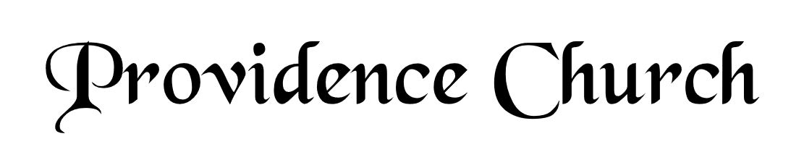
Prelude
Welcome and Announcements
Silent Prayer

* Opening Praise Doxology
Praise God from whom all blessings flow
Praise him, all creatures here below
Praise him above, ye heavenly host
Praise Father, Son, and Holy Ghost. Amen.

* Call to Worship Psalm 149
Leader: Sing to the LORD a new song,
People: His praise in the assembly of the godly!
Leader: Let Israel be glad in his Maker;
People: let the children of Zion rejoice in their King!
Leader: Jesus Christ is risen!
People: He is risen indeed!
* Prayer of Invocation

* Hymn
The Lord’s My Shepherd #23B

Scriptural Exhortation Isaiah 5:20-23

Prayer of Confession
Almighty God, we are unworthy to come into your presence, because of our many sins. We do not deserve any grace or mercy from you, if you dealt with us as we deserve. We have sinned against you, O Lord, and we have offended you. And yet, O Lord, as we acknowledge our sins and offenses, so also do we acknowledge you to be a merciful God, a loving and favorable Father, to all who turn to you. And so we humbly ask you, for the sake of Christ your son, to show mercy to us, and forgive us all our offenses. Forgive the sins of our youth, and the sins of our old age. By your Spirit, O God, take possession of our hearts, so that, not only the actions of our life, but also the words of our mouths, and the smallest thought of our minds, may be guided and governed by you. Through Jesus Christ our Lord, to whom, with you and the Holy Spirit, be all honor and glory, now and forever. Amen.
Assurance of Pardon Psalm 85:2-3

* Hymn of Response
Come, Thou Fount of Every Blessing #429

* Affirmation of Faith Westminster Larger Catechism
Q56: How is Christ to be exalted in his coming again to judge the world?
A56: Christ is to be exalted in his coming again to judge the world, in that he, who was unjustly judged and condemned by wicked men, shall come again at the last day in great power, and in the full manifestation of his own glory, and of his Father’s, with all his holy angels, with a shout, with the voice of the archangel, and with the trumpet of God, to judge the world in righteousness.

Q57: What benefits hath Christ procured by his mediation?
A57: Christ, by his mediation, hath procured redemption, with all other benefits of the covenant of grace.

Q58: How do we come to be made partakers of the benefits which Christ hath procured?
A58: We are made partakers of the benefits which Christ hath procured, by the application of them unto us, which is the work especially of God the Holy Ghost.

Prayer of the Congregation and Ruling Elder
The Lord’s Prayer Larry Watson
Our Father, Who art in heaven,
Hallowed be Thy name, Thy kingdom come,
Thy will be done, on earth as it is in heaven.
Give us this day our daily bread,
And forgive us our debts, as we forgive our debtors.
And lead us not into temptation,
But deliver us from evil,
For Thine is the kingdom, and the power,
And the glory forever, Amen.

Hymn
Holy, Holy, Holy! #230

Sermon Text Psalm 23
Sermon The Way Home Rev. Bill Fitzhenry

* The Apostles’ Creed
I believe in God the Father Almighty,
Maker of heaven and earth.
I believe in Jesus Christ, his only Son, our Lord
Who was conceived by the Holy Spirit,
And born of the virgin Mary,
He suffered under Pontius Pilate,
Was crucified, died, and was buried.
He descended into hell.
The third day he rose again from the dead.
He ascended into heaven.
And is seated at the right hand of God the Father Almighty.
From there He will come to judge the living and the dead.
I believe in the Holy Spirit, the holy catholic church,
The communion of saints, the forgiveness of sins,
The resurrection of the body, and the life Everlasting.

* Hymn
I Love to Tell the Story #438

* Benediction

