11:00 am October 26, 2025
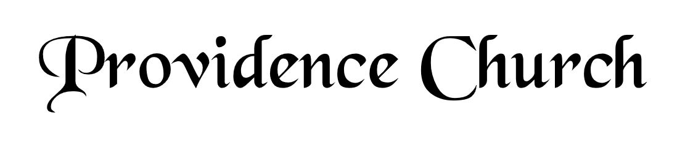
Prelude
Welcome and Announcements
Silent Prayer

* Opening Praise Doxology
Praise God from whom all blessings flow
Praise him, all creatures here below
Praise him above, ye heavenly host
Praise Father, Son, and Holy Ghost. Amen.

* Call to Worship Nehemiah 9
Leader: Stand up and praise the LORD your God, who is from everlasting to everlasting!
People: Blessed be Your glorious name, which is exalted above all blessing and praise.
Leader: You are the LORD, you alone!
People: You are the Creator and Preserver of all; You are the LORD, our God for Whom we gather to worship.
Leader: Jesus Christ is Risen!
People: He is Risen Indeed!
* Prayer of Invocation

* Hymn
Who, O Lord, with Thee Abiding #15B

Scriptural Exhortation Hebrews 12:1-2

Prayer of Confession
O Father, it is my duty to set You above all others, but it is my besetting sin to place myself above You. I am pained by my shallow prayers, my poverty of love, and my slowness in running the heavenly race. I have wasted hours and passed by opportunities to do good. Forgive me for my many sins through the blood of Christ. You have begun a good work in me, and You have promised that You will bring it to completion. Make me reflect my citizenship in heaven even as I live on earth. In Christ’s name. Amen.
Assurance of Pardon Psalm 86:3-5

* Hymn of Response
All Hail the Power of Jesus’ Name! #374

* Affirmation of Faith Westminster Larger Catechism
Q7: What is God?
A7: God is a Spirit, in and of himself infinite in being, glory, blessedness, and perfection; all-sufficient, eternal, unchangeable, incomprehensible, everywhere present, almighty, knowing all things, most wise, most holy, most just, most merciful and gracious, longsuffering, and abundant in goodness and truth.

Prayer of the Congregation and Ruling Elder
The Lord’s Prayer Glenn Dowling
Our Father, Who art in heaven,
Hallowed be Thy name, Thy kingdom come,
Thy will be done, on earth as it is in heaven.
Give us this day our daily bread,
And forgive us our debts, as we forgive our debtors.
And lead us not into temptation,
But deliver us from evil,
For Thine is the kingdom, and the power,
And the glory forever, Amen.
Hymn
A Mighty Fortress Is Our God #244

Sermon Text Psalm 46
Sermon A Mighty Fortress Rev. Mark Wheat

* The Apostles’ Creed
I believe in God the Father Almighty,
Maker of heaven and earth.
I believe in Jesus Christ, his only Son, our Lord
Who was conceived by the Holy Spirit,
And born of the virgin Mary,
He suffered under Pontius Pilate,
Was crucified, died, and was buried.
He descended into hell.
The third day he rose again from the dead.
He ascended into heaven.
And is seated at the right hand of God the Father Almighty.
From there He will come to judge the living and the dead.
I believe in the Holy Spirit, the holy catholic church,
The communion of saints, the forgiveness of sins,
The resurrection of the body, and the life Everlasting.

* Hymn
My Faith Looks Up to Thee #466

* Benediction
Nursery Volunteer Rotation
Sunday 10/26/2025  Tim & Tessie West | Sunday 11/2/2025  Larry & Jennifer Watson

