11:00 am October 19, 2025
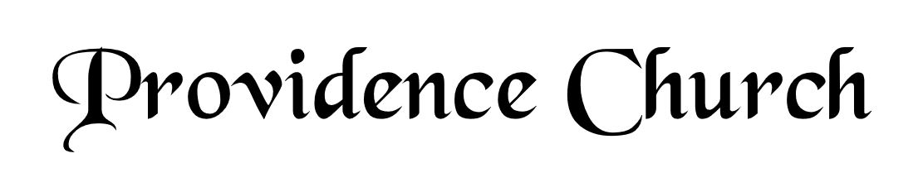
Prelude
Welcome and Announcements
Silent Prayer

* Opening Praise Doxology
Praise God from whom all blessings flow
Praise him, all creatures here below
Praise him above, ye heavenly host
Praise Father, Son, and Holy Ghost. Amen.

* Call to Worship Psalm 148
Leader: Make a joyful noise to the Lord, all the earth;
People: Break forth into joyous song and sing praises!
Leader: Sing praises to the Lord with the lyre,
People: With the lyre and the sound of melody!
Leader: With trumpets and the sound of the horn,
People: Make a joyful noise before the King, the Lord!
* Prayer of Invocation

* Hymn
Who, O Lord, with Thee Abiding #15B

Scriptural Exhortation Hebrews 12:1-2

Prayer of Confession
Father, I know that You can do all things, that no plan of Yours can be thwarted. Oh Lord, Your ways are just and true, and You are my Shepherd-King. I confess that I have not been living in Your light and truth, to show that I am living in fellowship with You. My faith is weak. Take away the self-centeredness that wrongly seeks to live my life on my terms instead of Yours. You are God; You are Light, and Life and Love. Through the blood of Christ forgive me for not being humble before You. Pour out Your Spirit in my life for faith and obedience to trust in You. My life is Yours. In Christ’s holy name. Amen.
Assurance of Pardon Romans 8:1-2

* Hymn of Response
My Hope Is Built on Nothing Less #459

* Affirmation of Faith Westminster Confession of Faith
20.1: The liberty which Christ hath purchased for believers under the gospel consists in their freedom from the guilt of sin, the condemning wrath of God, the curse of the moral law; and, in their being delivered from this present evil world, bondage to Satan, and dominion of sin; from the evil of afflictions, the sting of death, the victory of the grave, and everlasting damnation; as also, in their free access to God, and their yielding obedience unto him, not out of slavish fear, but a childlike love and willing mind. All which were common also to believers under the law. But, under the new testament, the liberty of Christians is further enlarged, in their freedom from the yoke of the ceremonial law, to which the Jewish church was subjected; and in greater boldness of access to the throne of grace, and in fuller communications of the free Spirit of God, than believers under the law did ordinarily partake of.

Prayer of the Congregation and Ruling Elder
The Lord’s Prayer Terry Larsen
Our Father, Who art in heaven,
Hallowed be Thy name, Thy kingdom come,
Thy will be done, on earth as it is in heaven.
Give us this day our daily bread,
And forgive us our debts, as we forgive our debtors.
And lead us not into temptation,
But deliver us from evil,
For Thine is the kingdom, and the power,
And the glory forever, Amen.

Hymn
Jesus, I Am Resting, Resting #479

Sermon Text Matthew 16:13-20
Sermon Upon the Rock Rev. Jonathan Brack

* The Apostles’ Creed
I believe in God the Father Almighty,
Maker of heaven and earth.
I believe in Jesus Christ, his only Son, our Lord
Who was conceived by the Holy Spirit,
And born of the virgin Mary,
He suffered under Pontius Pilate,
Was crucified, died, and was buried.
He descended into hell.
The third day he rose again from the dead.
He ascended into heaven.
And is seated at the right hand of God the Father Almighty.
From there He will come to judge the living and the dead.
I believe in the Holy Spirit, the holy catholic church,
The communion of saints, the forgiveness of sins,
The resurrection of the body, and the life Everlasting.

* Hymn
Love Divine, All Loves Excelling #465

* Benediction
Nursery Volunteer Rotation
Sunday 10/19/2025  Larry & Jennifer Watson | Sunday 10/26/2025  Tim & Tessie West

