11:00 am October 12, 2025
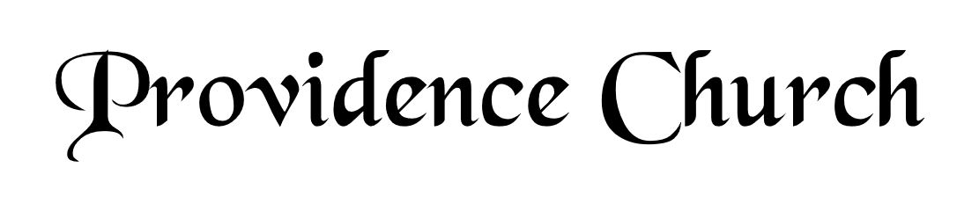
Prelude
Welcome and Announcements
Silent Prayer

* Opening Praise Doxology
Praise God from whom all blessings flow
Praise him, all creatures here below
Praise him above, ye heavenly host
Praise Father, Son, and Holy Ghost. Amen.

* Call to Worship Psalm 148
Leader: Praise the Lord! Praise the Lord from the heavens,
People: Praise Him from the height.
Leader: Praise Him all His angels, praise Him, all His host!
People: Praise Him, sun and moon, praise Him, all you shining stars!
Leader: Praise Him, you highest heavens!
People: Let them praise the name of the Lord!
* Prayer of Invocation

* Hymn
Who, O Lord, with Thee Abiding #15B

Scriptural Exhortation Psalm 1:1-3

Prayer of Confession
God of grace and truth, in Jesus Christ you came among us as light shining in darkness, bringing the good news of joy that mankind is reconciled to God through Jesus. We confess that we have not welcomed the light, or trusted the good news. We have closed our eyes to your glory in our midst, and have ignored your presence in the Spirit of our Lord Jesus Christ. And, barely acknowledging in our lives Jesus’ first coming, we have not watched diligently for the final coming of our Savior and Judge. Forgive our sin, and renew our hope in the gospel, so that we may receive the fullness of your grace, and live in the truth of Christ our Lord, in whose name we pray. Amen.
Assurance of Pardon Romans 5:8-10

* Hymn of Response
Lamb, Precious Lamb #353

* Affirmation of Faith Westminster Confession of Faith
Chapter 18, Paragraph 4: True believers may have the assurance of their salvation divers ways shaken, diminished, and intermitted; as, by negligence in preserving of it, by falling into some special sin which woundeth the conscience and grieveth the Spirit; by some sudden or vehement temptation, by God’s withdrawing the light of his countenance, and suffering even such as fear him to walk in darkness and to have no light: yet are they never utterly destitute of that seed of God, and life of faith, that love of Christ and the brethren, that sincerity of heart, and conscience of duty, out of which, by the operation of the Spirit, this assurance may, in due time, be revived; and by the which, in the meantime, they are supported from utter despair.

Prayer of the Congregation and Ruling Elder
The Lord’s Prayer Norval Sells
Our Father, Who art in heaven,
Hallowed be Thy name, Thy kingdom come,
Thy will be done, on earth as it is in heaven.
Give us this day our daily bread,
And forgive us our debts, as we forgive our debtors.
And lead us not into temptation,
But deliver us from evil,
For Thine is the kingdom, and the power,
And the glory forever, Amen.

Hymn
Come, Ye Sinners, Poor and Wretched #440

Sermon Text I Peter 1:1-2
Sermon I Peter: The Author and the Audience Rev. David Boxerman

* The Apostles’ Creed
I believe in God the Father Almighty,
Maker of heaven and earth.
I believe in Jesus Christ, his only Son, our Lord
Who was conceived by the Holy Spirit,
And born of the virgin Mary,
He suffered under Pontius Pilate,
Was crucified, died, and was buried.
He descended into hell.
The third day he rose again from the dead.
He ascended into heaven.
And is seated at the right hand of God the Father Almighty.
From there He will come to judge the living and the dead.
I believe in the Holy Spirit, the holy catholic church,
The communion of saints, the forgiveness of sins,
The resurrection of the body, and the life Everlasting.

* The Lord’s Supper

* Hymn
Praise to the Lord, the Almighty #216

* Benediction
Nursery Volunteer Rotation
Sunday 10/12/2025  Andrew & Regan van der Merwe | Sunday 10/19/2025  Larry & Jennifer Watson

