11:00 am September 7, 2025
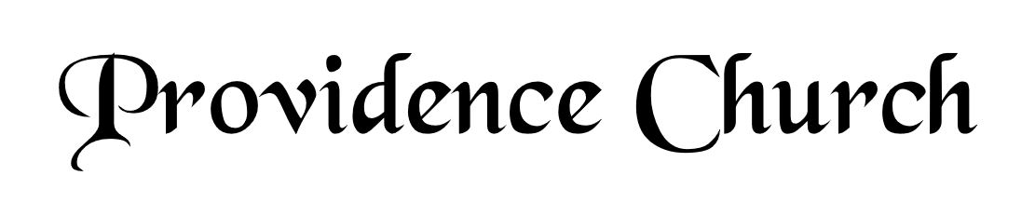
Prelude
Welcome and Announcements
Silent Prayer

* Opening Praise Doxology
Praise God from whom all blessings flow
Praise him, all creatures here below
Praise him above, ye heavenly host
Praise Father, Son, and Holy Ghost. Amen.

* Call to Worship Psalm 99
Leader: The Lord reigns; let the peoples tremble!
People: He sits enthroned upon the cherubim; let the earth quake!
Leader: The Lord is great in Zion;
People: He is exalted over all the peoples.
Leader: Jesus Christ is risen!
People: He is risen indeed!
* Prayer of Invocation

* Hymn
Be Merciful, O God #57

Scriptural Exhortation Matthew 22:34-40

Prayer of Confession
Gracious Father, we confess that with Adam, from the Garden, we have broken Your covenant. We daily fall short of Your standard of holiness. Because of our sin, we condemn ourselves daily. We deserve eternal death. Yet, Father, we thank You for Your mercy. While in our sin, You promised and sent Your Son to bear our sins. He has kept the covenant for us. He has lived and died on our behalf. Because of Your Son, Jesus Christ, forgive us. We thank You for the eternal life accomplished by what He has done for us. Renew us to live in Your strength, to do Your will. Through Christ we pray. Amen.
Assurance of Pardon I John 1:8-9

* Hymn of Response
God, in the Gospel of His Son #170

* Affirmation of Faith Westminster Larger Catechism
Q31: With whom was the covenant of grace made?
A31: The covenant of grace was made with Christ as the second Adam, and in him with all the elect as his seed.

Q32: How is the grace of God manifested in the second covenant?
A32: The grace of God is manifested in the second covenant, in that he freely provideth and offereth to sinners a mediator, and life and salvation by him; and requiring faith as the condition to interest them in him, promiseth and giveth his Holy Spirit to all his elect, to work in them that faith, with all other saving graces; and to enable them unto all holy obedience, as the evidence of the truth of their faith and thankfulness to God, and as the way which he hath appointed them to salvation.

Prayer of the Congregation and Ruling Elder
The Lord’s Prayer Norval Sells
Our Father, Who art in heaven,
Hallowed be Thy name, Thy kingdom come,
Thy will be done, on earth as it is in heaven.
Give us this day our daily bread,
And forgive us our debts, as we forgive our debtors.
And lead us not into temptation,
But deliver us from evil,
For Thine is the kingdom, and the power,
And the glory forever, Amen.

Hymn
O Father, You Are Sovereign #233

Sermon Text Mark 8:14-21
Sermon The Yeast that Corrupts Rev. Harry Monroe

* The Apostles’ Creed
I believe in God the Father Almighty,
Maker of heaven and earth.
I believe in Jesus Christ, his only Son, our Lord
Who was conceived by the Holy Spirit,
And born of the virgin Mary,
He suffered under Pontius Pilate,
Was crucified, died, and was buried.
He descended into hell.
The third day he rose again from the dead.
He ascended into heaven.
And is seated at the right hand of God the Father Almighty.
From there He will come to judge the living and the dead.
I believe in the Holy Spirit, the holy catholic church,
The communion of saints, the forgiveness of sins,
The resurrection of the body, and the life Everlasting.

* Hymn
O Word of God Incarnate #171

* Benediction

