11:00 am September 14, 2025
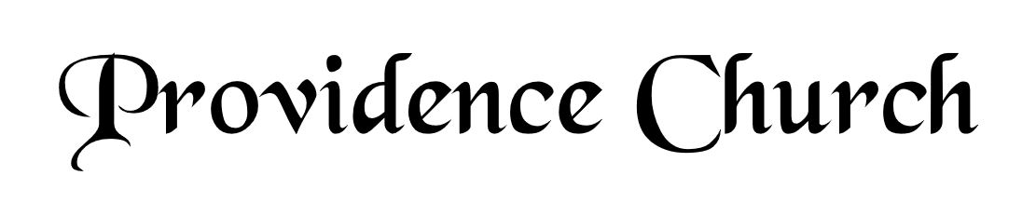
Prelude
Welcome and Announcements
Silent Prayer

* Opening Praise Doxology
Praise God from whom all blessings flow
Praise him, all creatures here below
Praise him above, ye heavenly host
Praise Father, Son, and Holy Ghost. Amen.

* Call to Worship Psalm 96
Leader: Ascribe to the Lord, O families of the peoples,
People: Ascribe to the Lord glory and strength!
Leader: Ascribe to the Lord the glory due His name;
People: Bring an offering and come into His courts!
Leader: Worship the Lord in holy array;
People: Tremble before Him all the earth!
* Prayer of Invocation

* Hymn
Be Merciful, O God #57

Scriptural Exhortation Hebrews 12:1-2

Prayer of Confession
O God of Grace, you have attributed my sin on my substitute, and have imputed his righteousness to my soul, clothing me with a bridegroom’s robe, a robe of holiness. But in my walk, my daily living, I am still in rags. I have no robe to cover my sins, no loom to weave my own righteousness; I am always standing clothed in filthy garments, and by grace alone do I receive a change of clothes. For you justify the ungodly. I am always going into the far country, and always returning home as a prodigal, always saying, Father, forgive me, and thou are always bringing forth the best robe. Every morning let me wear it, every evening return in it, go out to the day’s work in it, be married in it, be wound in death in it, stand before the throne in it, enter heaven in it shining as the sun. Grant me never to lost sight of the exceeding sinfulness of sin, the exceeding righteousness of salvation, the exceeding glory of Christ, the exceeding beauty of holiness, the exceeding wonder of grace. Amen.
Assurance of Pardon Psalm 86:3-5

* Hymn of Response
Come, Ye Sinners, Poor and Needy #439

* Affirmation of Faith Westminster Larger Catechism
Q41: Why was our mediator called Jesus?
A41: Our mediator was called Jesus, because he saveth his people from their sins.

Q42: Why was our mediator called Christ?
A42: Our mediator was called Christ, because he was anointed with the Holy Ghost above measure; and so set apart, and fully furnished with all authority and ability, to execute the offices of prophet, priest, and king of his church, in the estate both of his humiliation and exaltation.

Prayer of the Congregation and Ruling Elder
The Lord’s Prayer Terry Larsen
Our Father, Who art in heaven,
Hallowed be Thy name, Thy kingdom come,
Thy will be done, on earth as it is in heaven.
Give us this day our daily bread,
And forgive us our debts, as we forgive our debtors.
And lead us not into temptation,
But deliver us from evil,
For Thine is the kingdom, and the power,
And the glory forever, Amen.

Hymn
We Come, O Christ, to You #288

Sermon Text Mark 8:16-18, 22-26, 29
Sermon Sight for the Blind Rev. Harry Monroe

* The Apostles’ Creed
I believe in God the Father Almighty,
Maker of heaven and earth.
I believe in Jesus Christ, his only Son, our Lord
Who was conceived by the Holy Spirit,
And born of the virgin Mary,
He suffered under Pontius Pilate,
Was crucified, died, and was buried.
He descended into hell.
The third day he rose again from the dead.
He ascended into heaven.
And is seated at the right hand of God the Father Almighty.
From there He will come to judge the living and the dead.
I believe in the Holy Spirit, the holy catholic church,
The communion of saints, the forgiveness of sins,
The resurrection of the body, and the life Everlasting.

* Hymn
O for a Thousand Tongues to Sing #291

* Benediction

