11:00 am August 3, 2025
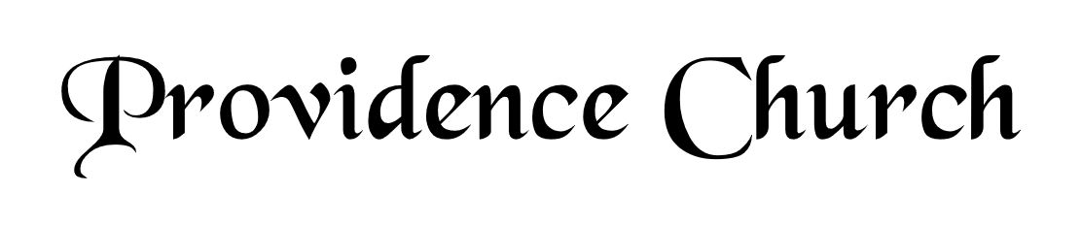
Prelude
Welcome and Announcements
Silent Prayer

* Opening Praise Doxology
Praise God from whom all blessings flow
Praise him, all creatures here below
Praise him above, ye heavenly host
Praise Father, Son, and Holy Ghost. Amen.

* Call to Worship Isaiah 12
Leader: Give thanks to the LORD, call upon His name!
People: Make known His deeds among the peoples, proclaim that His name is exalted.
Leader: Sing praises to the LORD!
People: For He has done gloriously!
Leader: Jesus Christ is risen!
People: He is risen, indeed!
* Prayer of Invocation

* Hymn
Sing Aloud to God Our Strength #81A

Scriptural Exhortation Matthew 22:34-40

Prayer of Confession
Almighty God, since thou delayst with so much forbearance the punishments which we have deserved and daily draw on ourselves, grant that we may not indulge ourselves but carefully consider how often and in how many different ways we have provoked thy wrath against us. May we learn humbly to present ourselves to thee for pardon, and with true repentance implore thy mercy. With all our heart we desire to submit ourselves to thee, whether thou chastises us, or according to thine infinite goodness, or forgives us. Let our condition be ever blessed, not by flattering ourselves in our apathy, but by finding thee to be our kind and bountiful Father, reconciled to us in thine only-begotten Son. Amen.
Assurance of Pardon Romans 5:8-10

* Hymn of Response
Alas! and Did My Savior Bleed #341

* Affirmation of Faith Westminster Larger Catechism
Q194: What do we pray for in the fifth petition?
A194: In the fifth petition (which is, Forgive us our debts, as we forgive our debtors), acknowledging that we and all others are guilty both of original and actual sin, and thereby become debtors to the justice of God; and that neither we, nor any other creature, can make the least satisfaction for that debt: we pray for ourselves and others, that God of his free grace would, through the obedience and satisfaction of Christ, apprehended and applied by faith, acquit us both from the guilt and punishment of sin, accept us in his Beloved; continue his favor and grace to us, pardon our daily failings, and fill us with peace and joy, in giving us daily more and more assurance of forgiveness; which we are the rather emboldened to ask, and encouraged to expect, when we have this testimony in ourselves, that we from the heart forgive others their offenses.

Prayer of the Congregation and Ruling Elder
The Lord’s Prayer Larry Watson
Our Father, Who art in heaven,
Hallowed be Thy name, Thy kingdom come,
Thy will be done, on earth as it is in heaven.
Give us this day our daily bread,
And forgive us our debts, as we forgive our debtors.
And lead us not into temptation,
But deliver us from evil,
For Thine is the kingdom, and the power,
And the glory forever, Amen.
Hymn
My Hope Is Built on Nothing Less #459

Sermon Text Mark 7:14-23
Sermon Inside Out
Rev. Harry Monroe

* The Nicene Creed
We believe in one God, the Father Almighty, Maker of heaven and earth, of all things visible and invisible.

And in one Lord Jesus Christ, the only-begotten Son of God, begotten of his Father before all worlds, God of God, Light of Light, very God of very God, begotten, not made, being of one substance with the Father; by whom all things were made; who for us and for our salvation came down from heaven, and was incarnate by the Holy Spirit of the virgin Mary, and was made man; and was crucified also for us under Pontius Pilate; he suffered and was buried; and the third day he rose again according to the Scriptures, and ascended into heaven, and is seated at the right hand of the Father; and he shall come again, with glory, to judge both the living and the dead; whose kingdom shall have no end.

And we believe in the Holy Spirit, the Lord and giver of life, who proceeds from the Father and the Son; who with the Father and the Son together is worshiped and glorified; who spoke by the prophets; and we believe in one holy catholic and apostolic church; we acknowledge one baptism for the remission of sins; and we look for the resurrection of the dead, and of the life of the world to come. Amen.

* Hymn
I Will Sing of My Redeemer #498

* Benediction

