11:00 am August 24, 2025
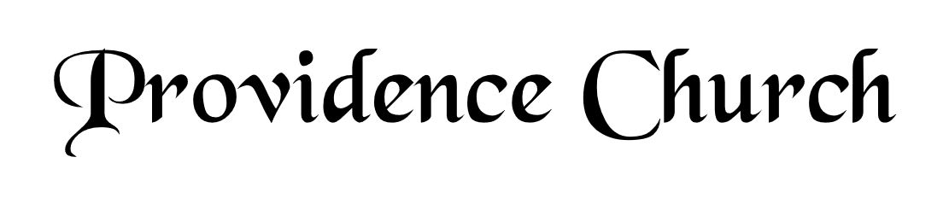
Prelude
Welcome and Announcements
Silent Prayer

* Opening Praise Doxology
Praise God from whom all blessings flow
Praise him, all creatures here below
Praise him above, ye heavenly host
Praise Father, Son, and Holy Ghost. Amen.

* Call to Worship Psalm 66
Leader: Come and hear, all you who fear God.
People: And I will declare what He has done for my soul.
Leader: I cried to Him with my mouth.
People: And He was extolled with my tongue.
Leader: Jesus Christ is risen!
People: He is risen, indeed!
* Prayer of Invocation

* Hymn
Sing Aloud to God Our Strength #81A

Scriptural Exhortation Colossians 3:5-10

Prayer of Confession
O God of Grace, you have attributed my sin on my substitute, and have imputed his righteousness to my soul, clothing me with a bridegroom’s robe, a robe of holiness. But in my walk, my daily living, I am still in rags. I have no robe to cover my sins, no loom to weave my own righteousness; I am always standing clothed in filthy garments, and by grace alone do I receive a change of clothes. For you justify the ungodly. I am always going into the far country, and always returning home as a prodigal, always saying, Father, forgive me, and thou are always bringing forth the best robe. Every morning let me wear it, every evening return in it, go out to the day’s work in it, be married in it, be wound in death in it, stand before the throne in it, enter heaven in it shining as the sun. Grant me never to lose sight of: the exceeding sinfulness of sin, the exceeding righteousness of salvation, the exceeding glory of Christ, the exceeding beauty of holiness, the exceeding wonder of grace. Amen.
Assurance of Pardon Romans 5:6-9

* Hymn of Response
Savior, like a Shepherd Lead Us #525

* Affirmation of Faith Heidelberg Catechism
Q1: What is your only comfort in life and in death?
A1. That I am not my own, but belong — body and soul, in life and in death — to my faithful Savior, Jesus Christ. He has fully paid for all my sins with his precious blood, and has set me free from the tyranny of the devil. He also watches over me in such a way that not a hair can fall from my head without the will of my Father in heaven; in fact, all things must work together for my salvation. Because I belong to him, Jesus, by his Holy Spirit, assures me of eternal life and makes me wholeheartedly willing and ready from now on to live for Him.

Prayer of the Congregation and Ruling Elder
The Lord’s Prayer Norval Sells
Our Father, Who art in heaven,
Hallowed be Thy name, Thy kingdom come,
Thy will be done, on earth as it is in heaven.
Give us this day our daily bread,
And forgive us our debts, as we forgive our debtors.
And lead us not into temptation,
But deliver us from evil,
For Thine is the kingdom, and the power,
And the glory forever, Amen.

Hymn
Break Thou the Bread of Life #273

Sermon Text Mark 8:1-10
Sermon Food for the Faint Rev. Harry Monroe

* The Apostles’ Creed
I believe in God the Father Almighty,
Maker of heaven and earth.
I believe in Jesus Christ, his only Son, our Lord
Who was conceived by the Holy Spirit,
And born of the virgin Mary,
He suffered under Pontius Pilate,
Was crucified, died, and was buried.
He descended into hell.
The third day he rose again from the dead.
He ascended into heaven.
And is seated at the right hand of God the Father Almighty.
From there He will come to judge the living and the dead.
I believe in the Holy Spirit, the holy catholic church,
The communion of saints, the forgiveness of sins,
The resurrection of the body, and the life Everlasting.

* Hymn
Guide Me, O Thou Great Jehovah #524

* Benediction

