11:00 am August 10, 2025
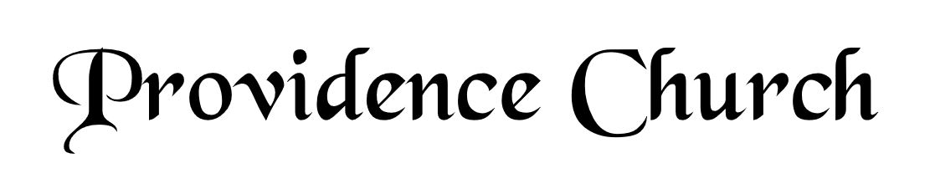
Prelude
Welcome and Announcements
Silent Prayer

* Opening Praise Doxology
Praise God from whom all blessings flow
Praise him, all creatures here below
Praise him above, ye heavenly host
Praise Father, Son, and Holy Ghost. Amen.

* Call to Worship Psalm 105
Leader: O give thanks to the LORD; call upon His name.
People: Make known His deeds among the peoples!
Leader: Sing to Him, sing praises to Him.
People: Tell of all His wondrous works!
Leader: Jesus Christ is risen!
People: He is risen, indeed!
* Prayer of Invocation

* Hymn
Sing Aloud to God Our Strength #81A

Scriptural Exhortation Psalm 25:8-10

Prayer of Confession
Almighty Father; we enter your presence confessing the things we try to conceal from you and the things we try to conceal from others. We confess the heartbreak, worry, and sorrow we have caused, that make it difficult for others to forgive us, the times we have made it easy for others to do wrong, the harm we have done that makes it hard for us to forgive ourselves. Lord have mercy and forgive us through Christ. Amen.
Assurance of Pardon Psalm 130:1-4

* Hymn of Response
I Have No Other Comfort #480

* Affirmation of Faith Westminster Larger Catechism
Q72: What is justifying faith?
A72: Justifying faith is a saving grace, wrought in the heart of a sinner by the Spirit and Word of God, whereby he, being convinced of his sin and misery, and of the disability in himself and all other creatures to recover him out of his lost condition, not only assenteth to the truth of the promise of the gospel, but receiveth and resteth upon Christ and his righteousness, therein held forth, for pardon of sin, and for the accepting and accounting of his person righteous in the sight of God for salvation.

Q73: How doth faith justify a sinner in the sight of God?
A73: Faith justifies a sinner in the sight of God, not because of those other graces which do always accompany it, or of good works that are the fruits of it, nor as if the grace of faith, or any act thereof, were imputed to him for his justification; but only as it is an instrument by which he receiveth and applieth Christ and his righteousness.

Prayer of the Congregation and Ruling Elder
The Lord’s Prayer Glenn Dowling
Our Father, Who art in heaven,
Hallowed be Thy name, Thy kingdom come,
Thy will be done, on earth as it is in heaven.
Give us this day our daily bread,
And forgive us our debts, as we forgive our debtors.
And lead us not into temptation,
But deliver us from evil,
For Thine is the kingdom, and the power,
And the glory forever, Amen.

Hymn
Rock of Ages, Cleft for Me #452

Sermon Text Mark 7:24-30
Sermon Crumbs from the Table
Rev. Harry Monroe

* The Apostles’ Creed
I believe in God the Father Almighty,
Maker of heaven and earth.
I believe in Jesus Christ, his only Son, our Lord
Who was conceived by the Holy Spirit,
And born of the virgin Mary,
He suffered under Pontius Pilate,
Was crucified, died, and was buried.
He descended into hell.
The third day he rose again from the dead.
He ascended into heaven.
And is seated at the right hand of God the Father Almighty.
From there He will come to judge the living and the dead.
I believe in the Holy Spirit, the holy catholic church,
The communion of saints, the forgiveness of sins,
The resurrection of the body, and the life Everlasting.

* Hymn
In Christ Alone #265

* Benediction

