11:00 am July 13, 2025
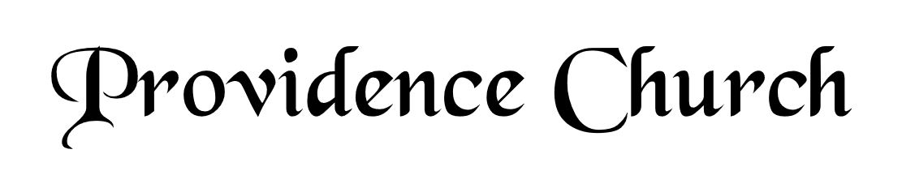
Prelude
Welcome and Announcements
Silent Prayer

* Opening Praise Doxology
Praise God from whom all blessings flow
Praise him, all creatures here below
Praise him above, ye heavenly host
Praise Father, Son, and Holy Ghost. Amen.

* Call to Worship Psalm 96
Leader: O sing to the LORD a new song:
People: Sing to the LORD, all the earth.
Leader: Sing to the LORD, bless his name.
People: Tell of his salvation from day to day.
Leader: Jesus Christ is risen!
People: He is risen indeed!
* Prayer of Invocation

* Hymn
Remember Not, O God #79B

Scriptural Exhortation Romans 12:1-2

Prayer of Confession
Most merciful God, we confess that we have sinned against you in thought, word, and deed, by what we have done, and by what we have left undone. We have not loved you with our whole heart; we have not loved our neighbors as ourselves. We are truly sorry and we humbly repent, for the sake of your Son Jesus Christ, have mercy on us and forgive us; that we may delight in your will, and walk in your ways, to the glory of your Name. Amen.
Assurance of Pardon Psalm 130:3-4

* Hymn of Response
Jesus, Lover of My Soul #450

* Affirmation of Faith Heidelberg Catechism
Q1: What is your only comfort in life and in death?
A1. That I am not my own, but belong — body and soul, in life and in death — to my faithful Savior, Jesus Christ. He has fully paid for all my sins with his precious blood, and has set me free from the tyranny of the devil. He also watches over me in such a way that not a hair can fall from my head without the will of my Father in heaven; in fact, all things must work together for my salvation. Because I belong to him, Jesus, by his Holy Spirit, assures me of eternal life and makes me wholeheartedly willing and ready from now on to live for Him.

Prayer of the Congregation and Ruling Elder
The Lord’s Prayer Larry Watson
Our Father, Who art in heaven,
Hallowed be Thy name, Thy kingdom come,
Thy will be done, on earth as it is in heaven.
Give us this day our daily bread,
And forgive us our debts, as we forgive our debtors.
And lead us not into temptation,
But deliver us from evil,
For Thine is the kingdom, and the power,
And the glory forever, Amen.

Hymn
Jesus! What a Friend for Sinners! #456

Sermon Text Mark 6:53-56
Sermon The Savior Among the Sick Rev. Harry Monroe

* The Apostles’ Creed
I believe in God the Father Almighty,
Maker of heaven and earth.
I believe in Jesus Christ, his only Son, our Lord
Who was conceived by the Holy Spirit,
And born of the virgin Mary,
He suffered under Pontius Pilate,
Was crucified, died, and was buried.
He descended into hell.
The third day he rose again from the dead.
He ascended into heaven.
And is seated at the right hand of God the Father Almighty.
From there He will come to judge the living and the dead.
I believe in the Holy Spirit, the holy catholic church,
The communion of saints, the forgiveness of sins,
The resurrection of the body, and the life Everlasting.

* Hymn
It Is Well with My Soul #476

* Benediction

