11:00 am July 6, 2025
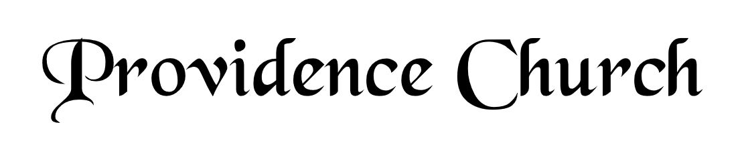
Prelude
Welcome and Announcements
Silent Prayer

* Opening Praise Doxology
Praise God from whom all blessings flow
Praise him, all creatures here below
Praise him above, ye heavenly host
Praise Father, Son, and Holy Ghost. Amen.

* Call to Worship Psalm 33
Leader: Shout for joy in the LORD, O you righteous!
People: Praise befits the upright. Give thanks to the LORD with the lyre.
Leader: Make melody to Him with the harp of ten strings.
People: Sing to Him a new song; play skillfully on the strings, with loud shouts.
Leader: Jesus Christ Is Risen!
People: He Is Risen Indeed!
* Prayer of Invocation

* Hymn
Remember Not, O God #79B

Scriptural Exhortation Psalm 25:4-8

Prayer of Confession
Dear Heavenly Father, You have made me for Your glory and service. I know my life belongs to You, but I live as if it were mine to do with as I please. I have been self-serving. I have boasted in myself and my accomplishments. Take away my sins through Christ’s shed blood, and renew me with an undivided heart. Fill me with Your Holy Spirit. Help me to serve You in faithfulness with my time, talents, relationships, health, and finances in every area of my life. Through Christ I pray. Amen.
Assurance of Pardon Romans 5:8-10

* Hymn of Response
When I Survey the Wondrous Cross #338

* Affirmation of Faith Westminster Larger Catechism
Q54: How is Christ exalted in his sitting at the right hand of God?
A54: Christ is exalted in his sitting at the right hand of God, in that as God-man he is advanced to the highest favor with God the Father, with all fullness of joy, glory, and power over all things in heaven and earth; and doth gather and defend his church, and subdue their enemies; furnisheth his ministers and people with gifts and graces, and maketh intercession for them.

Q56: How is Christ to be exalted in his coming again to judge the world?
A56: Christ is to be exalted in his coming again to judge the world, in that he, who was unjustly judged and condemned by wicked men, shall come again at the last day in great power, and in the full manifestation of his own glory, and of his Father’s, with all his holy angels, with a shout, with the voice of the archangel, and with the trumpet of God, to judge the world in righteousness.

Prayer of the Congregation and Ruling Elder
The Lord’s Prayer Glenn Dowling
Our Father, Who art in heaven,
Hallowed be Thy name, Thy kingdom come,
Thy will be done, on earth as it is in heaven.
Give us this day our daily bread,
And forgive us our debts, as we forgive our debtors.
And lead us not into temptation,
But deliver us from evil,
For Thine is the kingdom, and the power,
And the glory forever, Amen.
Hymn
Let All Things Now Living #254

Sermon Text Mark 6:45-52
Sermon Walking on the Foaming Deep Rev. Harry Monroe

* The Apostles’ Creed
We believe in one God, the Father Almighty, Maker of heaven and earth, of all things visible and invisible.

And in one Lord Jesus Christ, the only-begotten Son of God, begotten of his Father before all worlds, God of God, Light of Light, very God of very God, begotten, not made, being of one substance with the Father; by whom all things were made; who for us and for our salvation came down from heaven, and was incarnate by the Holy Spirit of the virgin Mary, and was made man; and was crucified also for us under Pontius Pilate; he suffered and was buried; and the third day he rose again according to the Scriptures, and ascended into heaven, and is seated at the right hand of the Father; and he shall come again, with glory, to judge both the living and the dead; whose kingdom shall have no end.

And we believe in the Holy Spirit, the Lord and giver of life, who proceeds from the Father and the Son; who with the Father and the Son together is worshiped and glorified; who spoke by the prophets; and we believe in one holy catholic and apostolic church; we acknowledge one baptism for the remission of sins; and we look for the resurrection of the dead, and of the life of the world to come. Amen.

* Hymn
We Praise You, O God, Our Redeemer, Creator #247

* Benediction

