11:00 am June 8, 2025
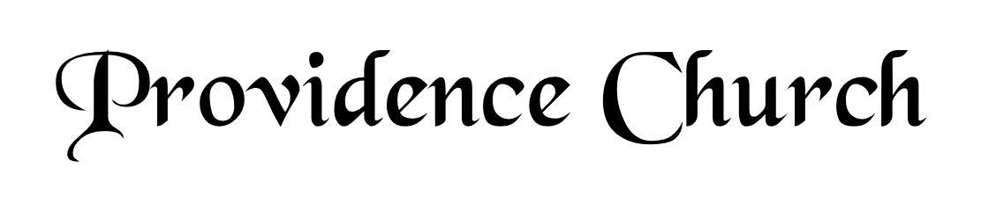
Prelude
Welcome and Announcements
Silent Prayer

* Opening Praise Doxology
Praise God from whom all blessings flow
Praise him, all creatures here below
Praise him above, ye heavenly host
Praise Father, Son, and Holy Ghost. Amen.

* Call to Worship Psalm 2:7-9
Leader: I will tell of the decree of the Lord:
People: He said to me, “You are my son, today I have begotten you.
Leader: Ask of me and I will make the nations your heritage.
People: And the ends of the earth your possession.
Leader: You shall break them with a rod of iron,
People: And dash them in pieces like a potter’s vessel.”
Leader: Jesus Christ Is Risen!
People: He Is Risen Indeed!
* Prayer of Invocation

* Hymn
In You, LORD, I Take Refuge #71
(Stanzas 1, 5-8)

Scriptural Exhortation Colossians 3:5-10

Prayer of Confession
Holy Father, we come before You in the righteousness of Christ, through whom we've been forgiven and justified, and we are thankful. We acknowledge Your claim on us: that we pursue righteousness—holy and obedient living that is blameless before God and man. How far we have fallen short in this. We confess that we have not pursued it with all our strength. We have not hated sin and loved righteousness, often doing the opposite instead. Please forgive our lukewarmness toward godly living. Wash us in the blood of our righteous Substitute, that we might die to sin and live to righteousness. For Jesus' sake we pray. Amen.
Assurance of Pardon I John 1: 8-9

* Hymn of Response
Lamb, Precious Lamb #353

* Affirmation of Faith Westminster Larger Catechism
Q9: How many persons are there in the Godhead?
A9: There be three persons in the Godhead, the Father, the Son, and the Holy Ghost; and these three are one true, eternal God, the same in substance, equal in power and glory; although distinguished by their personal properties.

Q10: What are the personal properties of the three persons in the Godhead?
A10: It is proper to the Father to beget the Son, and to the Son to be begotten of the Father, and to the Holy Ghost to proceed from the Father and the Son from all eternity.

Q11: How doth it appear that the Son and the Holy Ghost are God equal with the Father?
A11: The Scriptures manifest that the Son and the Holy Ghost are God equal with the Father, ascribing unto them such names, attributes, works, and worship, as are proper to God only.

Prayer of the Congregation and Teaching Elder
The Lord’s Prayer Harry Monroe
Our Father, Who art in heaven,
Hallowed be Thy name, Thy kingdom come,
Thy will be done, on earth as it is in heaven.
Give us this day our daily bread,
And forgive us our debts, as we forgive our debtors.
And lead us not into temptation,
But deliver us from evil,
For Thine is the kingdom, and the power,
And the glory forever, Amen.

Hymn
And Can It Be That I Should Gain #431
(Stanzas 1, 3, 5)

Sermon Text Mark 6:1-6
Sermon Amazing Wretchedness Rev. Harry Monroe

* The Apostles’ Creed
I believe in God the Father Almighty,
Maker of heaven and earth.
I believe in Jesus Christ, his only Son, our Lord
Who was conceived by the Holy Spirit,
And born of the virgin Mary,
He suffered under Pontius Pilate,
Was crucified, died, and was buried.
He descended into hell.
The third day he rose again from the dead.
He ascended into heaven.
And is seated at the right hand of God the Father Almighty.
From there He will come to judge the living and the dead.
I believe in the Holy Spirit, the holy catholic church,
The communion of saints, the forgiveness of sins,
The resurrection of the body, and the life Everlasting.

* Hymn
All Glory, Laud, and Honor #325

* Benediction

