11:00 am June 15, 2025
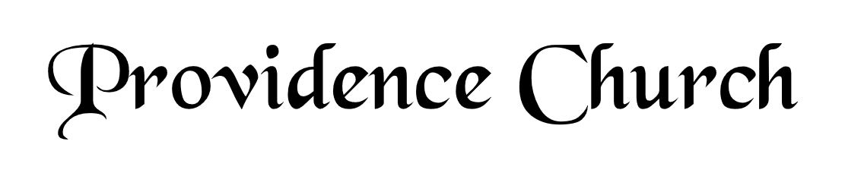
Prelude
Welcome and Announcements
Silent Prayer

* Opening Praise Doxology
Praise God from whom all blessings flow
Praise him, all creatures here below
Praise him above, ye heavenly host
Praise Father, Son, and Holy Ghost. Amen.

* Call to Worship Isaiah 53
Leader: Therefore, I will divide him a portion with the great,
People: And he shall divide the spoil with the strong;
Leader: Because he poured out his soul to death,
People: And was numbered with the transgressors;
Leader: Yet he bore the sin of many,
People: And made intercession for the transgressors.
Leader: Jesus Christ is risen!
People: He is risen indeed!
* Prayer of Invocation

* Hymn
In You, LORD, I Take Refuge #71
(Stanzas 1-4)

Scriptural Exhortation Hebrews 12:1-2

Prayer of Confession
Gracious Father, You have shown us in Your Word how we are to glorify You – by living according to Your Word. However, we have often gone our own way. We have not lived using the Scriptures as the only rule to direct us. We have sought our own wisdom and the wisdom of the world. Forgive us and cleanse us by the shed blood of Christ. Help us to use Your Word. Help us to seek You in it, that we might glorify and enjoy You. In Christ’s name we pray. Amen.
Assurance of Pardon Psalm 130:3-4

* Hymn of Response
Rejoice, Ye Pure in Heart #528

* Affirmation of Faith Westminster Larger Catechism
Q163: What are the parts of a sacrament?
A163: The parts of a sacrament are two; the one an outward and sensible sign, used according to Christ’s own appointment; the other an inward and spiritual grace thereby signified.

Q164: How many sacraments hath Christ instituted in his church under the New Testament?
A164: Under the New Testament Christ hath instituted in his church only two sacraments, baptism and the Lord’s supper.

Prayer of the Congregation and Ruling Elder
The Lord’s Prayer Dan Wilkerson
Our Father, Who art in heaven,
Hallowed be Thy name, Thy kingdom come,
Thy will be done, on earth as it is in heaven.
Give us this day our daily bread,
And forgive us our debts, as we forgive our debtors.
And lead us not into temptation,
But deliver us from evil,
For Thine is the kingdom, and the power,
And the glory forever, Amen.

Hymn
Lift High the Cross #287

Sermon Text Mark 6:7-13
Sermon Kingdom Missions Rev. Harry Monroe

* The Nicene Creed
We believe in one God, the Father Almighty, Maker of heaven and earth, of all things visible and invisible.
And in one Lord Jesus Christ, the only-begotten Son of God, begotten of his Father before all worlds, God of God, Light of Light, very God of very God, begotten, not made, being of one substance with the Father; by whom all things were made; who for us and for our salvation came down from heaven, and was incarnate by the Holy Spirit of the virgin Mary, and was made man; and was crucified also for us under Pontius Pilate; he suffered and was buried; and the third day he rose again according to the Scriptures, and ascended into heaven, and is seated at the right hand of the Father; and he shall come again, with glory, to judge both the living and the dead; whose kingdom shall have no end.
And we believe in the Holy Spirit, the Lord and giver of life, who proceeds from the Father and the Son; who with the Father and the Son together is worshiped and glorified; who spoke by the prophets; and we believe in one holy catholic and apostolic church; we acknowledge one baptism for the remission of sins; and we look for the resurrection of the dead, and of the life of the world to come. Amen.

*The Lord’s Supper

* Hymn
Praise God for Joy of Sabbath Blest #155

* Benediction

