11:00 am June 1, 2025
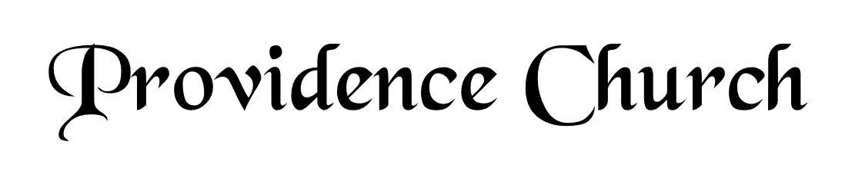
Prelude
Welcome and Announcements
Silent Prayer

* Opening Praise Doxology
Praise God from whom all blessings flow
Praise him, all creatures here below
Praise him above, ye heavenly host
Praise Father, Son, and Holy Ghost. Amen.

* Call to Worship Psalm 100
Leader: Make a joyful noise to the Lord, all the lands!
People: Serve the Lord with gladness!
Leader: Come into His presence with singing!
People: Know that the Lord is God!
Leader: It is He that made us, and we are His,
People: We are His people and the sheep of His pasture.
Leader: Enter His gates with thanksgiving, and His courts with praise!
People: Give thanks to Him, bless His name!
* Prayer of Invocation

* Hymn
In You, LORD, I Take Refuge #71
(Stanzas 1-4)

Scriptural Exhortation Hebrews 12:1-2

Prayer of Confession
Gracious Father, You have shown us in Your Word how we are to glorify You – by living according to Your Word. However, we have often gone our own way. We have not lived using the Scriptures as the only rule to direct us. We have sought our own wisdom and the wisdom of the world. Forgive us and cleanse us by the shed blood of Christ. Help us to use Your Word. Help us to seek You in it, that we might glorify and enjoy You. In Christ’s name we pray. Amen.
Assurance of Pardon Psalm 130:3-4

* Hymn of Response
I Know Whom I Have Believed #517

* Affirmation of Faith Westminster Larger Catechism
Q52: How was Christ exalted in his resurrection?
A52: Christ was exalted in his resurrection, in that, not having seen corruption in death (of which it was not possible for him to be held), and having the very same body in which he suffered, with the essential properties thereof (but without mortality, and other common infirmities belonging to this life), really united to his soul, he rose again from the dead the third day by his own power; whereby he declared himself to be the Son of God, to have satisfied divine justice, to have vanquished death, and him that had power of it, and to be Lord of quick and dead: all which he did as a public person, the head of his church, for their justification, quickening in grace, support against enemies, and to assure them of their resurrection from the dead at the last day.

Prayer of the Congregation and Ruling Elder
The Lord’s Prayer Glenn Dowling
Our Father, Who art in heaven,
Hallowed be Thy name, Thy kingdom come,
Thy will be done, on earth as it is in heaven.
Give us this day our daily bread,
And forgive us our debts, as we forgive our debtors.
And lead us not into temptation,
But deliver us from evil,
For Thine is the kingdom, and the power,
And the glory forever, Amen.

Hymn
More Than Conquerors #515

Sermon Text Mark 5:21-43
Sermon The Defeat of Death
Rev. Harry Monroe

* The Apostles’ Creed
I believe in God the Father Almighty,
Maker of heaven and earth.
I believe in Jesus Christ, his only Son, our Lord
Who was conceived by the Holy Spirit,
And born of the virgin Mary,
He suffered under Pontius Pilate,
Was crucified, died, and was buried.
He descended into hell.
The third day he rose again from the dead.
He ascended into heaven.
And is seated at the right hand of God the Father Almighty.
From there He will come to judge the living and the dead.
I believe in the Holy Spirit, the holy catholic church,
The communion of saints, the forgiveness of sins,
The resurrection of the body, and the life Everlasting.

* Hymn
O for a Thousand Tongues to Sing #291

* Benediction

