11:00 am May 25, 2025
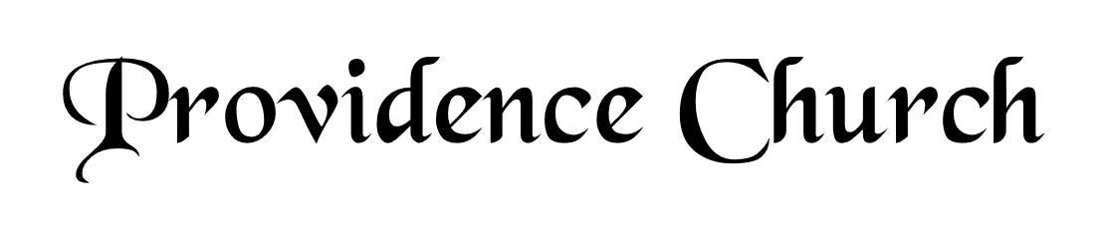
Prelude
Welcome and Announcements
Silent Prayer

* Opening Praise Doxology
Praise God from whom all blessings flow
Praise him, all creatures here below
Praise him above, ye heavenly host
Praise Father, Son, and Holy Ghost. Amen.

* Call to Worship Psalm 121
Leader: I Lift up my eyes to the hills.
People: From where does my help come?
Leader: My help comes from the LORD,
People: Who made heaven and earth.
Leader: Jesus Christ is Risen!
People: He is Risen indeed!
* Prayer of Invocation

* Hymn
God, My King, Thy Might Confessing #145D

Scriptural Exhortation Colossians 3:5-10

Prayer of Confession
Holy Father, we come before You in the righteousness of Christ, through whom we've been forgiven and justified, and we are thankful. We acknowledge Your claim on us: that we pursue righteousness—holy and obedient living that is blameless before God and man. How far we have fallen short in this. We confess that we have not pursued it with all our strength. We have not hated sin and loved righteousness, often doing the opposite instead. Please forgive our lukewarmness toward godly living. Wash us in the blood of our righteous Substitute, that we might die to sin and live to righteousness. For Jesus' sake we pray. Amen.
Assurance of Pardon I John 1: 8-9

* Hymn of Response
Amazing Grace! #433

* Affirmation of Faith Westminster Larger Catechism
Q57: What benefits hath Christ procured by his mediation?
A57: Christ, by his mediation, hath procured redemption, with all other benefits of the covenant of grace.

Q58: How do we come to be made partakers of the benefits which Christ hath procured?
A58: We are made partakers of the benefits which Christ hath procured, by the application of them unto us, which is the work especially of God the Holy Ghost.

Q59: Who are made partakers of redemption through Christ?
A59: Redemption is certainly applied, and effectually communicated, to all those for whom Christ hath purchased it; who are in time by the Holy Ghost enabled to believe in Christ according to the gospel.

Prayer of the Congregation and Ruling Elder
The Lord’s Prayer Norval Sells
Our Father, Who art in heaven,
Hallowed be Thy name, Thy kingdom come,
Thy will be done, on earth as it is in heaven.
Give us this day our daily bread,
And forgive us our debts, as we forgive our debtors.
And lead us not into temptation,
But deliver us from evil,
For Thine is the kingdom, and the power,
And the glory forever, Amen.

Hymn
I Love to Tell the Story #438

Sermon Text Psalm 119:176
Sermon A Lost Sheep: Saved
Rev. Bill Fitzhenry

* The Apostles’ Creed
I believe in God the Father Almighty,
Maker of heaven and earth.
I believe in Jesus Christ, his only Son, our Lord
Who was conceived by the Holy Spirit,
And born of the virgin Mary,
He suffered under Pontius Pilate,
Was crucified, died, and was buried.
He descended into hell.
The third day he rose again from the dead.
He ascended into heaven.
And is seated at the right hand of God the Father Almighty.
From there He will come to judge the living and the dead.
I believe in the Holy Spirit, the holy catholic church,
The communion of saints, the forgiveness of sins,
The resurrection of the body, and the life Everlasting.

* Hymn
LORD, Let My Cry before You Come #119V

* Benediction

